Ray Smith's Patent Notes:
- Background Section
  - Two basic Techniques in OCR:
    - Feature Extraction
      - Recognition of selected features of characters and comparison of those features with stored versions of the features on which the system has been trained
      - Better able to read many different fonts
    - Matrix Matching
      - Compares the bitmapped image of a character to a set of templates
      - Limited to certain fonts and very susceptible to character spacing
  - Aside from that, the background section is really repetitive. It goes over seven aspects of the invention, however several of them seem to be the same as their predecessor. They all start with scanning, then edge extraction, segmentation, polygonal approximation, feature extraction.. nothing is explained beyond that.

- Brief Description of the Drawings
  - Helpful for getting initially acquainted with the drawings and what topics they are covering, but aside from that not very instructive

Overview:

    - Scanner/Interface:
      - Explanation of how a scanner works, puts emphasis on the fact that the pages are scanned in gray scale

    - Edge Extraction:
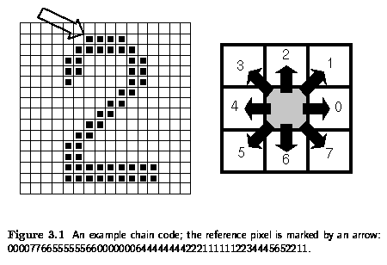
      - Chain code:

      - Discusses the advantages to using a gray scale image over a thresholded one:
        - Looking for edges rather than black segments allows for the recognition of any color of text on the background of any color provided that the contrast between the two is great enough.
        - Looking for closed-loop edges provides better discrimination between text and non-text since much of the edges in an image will not form a closed-loop and will thus be rejected.
        - Grayscale images have better quality than thresholded ones
      - The output of the edge extractor is a long sequence of steps between neighboring pixels, representing the outlines of the characters on the page.

    - Polygonal Approximation
      - The outline of each character is approximated by sequences of straight line segments (polygons)
      - Discusses two main reasons for approximating the outlines:
        - Both polygonal approximation and feature extraction consume linear time with respect to the number of points on the polygon, however the constant of proportionality between the amount of time and the number of points is much higher in the case of feature extraction. Thus the polygonal approximation saves a significant amount of time.
        - One of the most important features in this character recognition system are concave regions in the outline. The polygonal approximation eliminates the zigzags that might produce false concavities thereby confusing the system.
      - The output of the polygonal approximation is a series of image blobs each of which represents the edge path of a character along with its bounding box information. This is fed as the primary input to the text ordering, feature extraction, and merger/segmenter modules.
    - Feature Extraction
      - The features which are extracted by this module are as follows:
        - Concavities
          - Areas which can be filled and which may contain some convex points
        - Closures
          - Areas in the background which are completely enclosed by the character. For instance “e” and “p” have one closure while “B” has two. Sometimes the whitespace within the enclosure of such a character may not be entirely enclosed. For this reason, the feature extractor is designed to look for “functional” closures rather than only “physical” enclosures.
        - Lines
          - A straight part of the outline. Although after polygonal approximation, the character outline will consist of many straight lines, characters with curves will have distinctively shorter lines than characters that are less curvy.
        - Axes
          - Measures the ratio of the major and minor axes of a convex object. Can distinguish between a character that is a dot and one that is a straight line comma.
        - Symmetry
          - Measured by comparing parts of the character on either side of an axis. In italicized text the axis of symmetry is not perpendicular to the direction of measurement
      - Using these features, an unknown character is mapped to a generic character class (set of characters with similar features). Some characters reside in multiple character classes since they come in varying shapes, for instance “g” can have a single enclosure or two enclosures depending on the font. A single character class will most often also map to multiple characters. For instance the characters “1” (one), “l”, and “I” are often identical and the only way to distinguish them is by context. The same characters could also map to multiple character classes since they may come in different shapes depending on the font they are in.
    - Text Ordering
      - The main function of the text ordering process is to identify the document structure and to extract the correct ordering of the text within the document. The main steps are as follows:
        - Identify separate regions (blocks) within the document
        - Classify the blocks into text or graphics
        - Order text blocks into logical reading sequence
        - Order text blocks into character order
        - Deduce white space characters
        - Associate parts of deliberately broken characters (shouldn't this be in the merger/segmenter module??)
        - Identify potentially merged characters
        - Resolve intrinsic character ambiguities by geometry
    - Merger/Segmenter
      - Makes an attempt to merge the outlines of two or more blobs that have been identified as an unintentionally broken character or to segment the outline of a blob which has been identified as the ligature of two or more characters.
      - This give the system the capability of reading relatively poor quality copies of the text such as the output of a photocopier.
    - Final Classifier
      - Makes the final decision as to the character associated with each blob by resolving any outstanding ambiguities. For example, the final classifier can discriminate upper and lower case letters by using contextual information. It can also use contextual information to resolve difficult ambiguities such as distinguishing between the number “1”, letter “l”, and a capital “I”. The techniques available to the final classifier include lexical rules (such as no numbers within words), Markov chain analysis, and dictionary search.

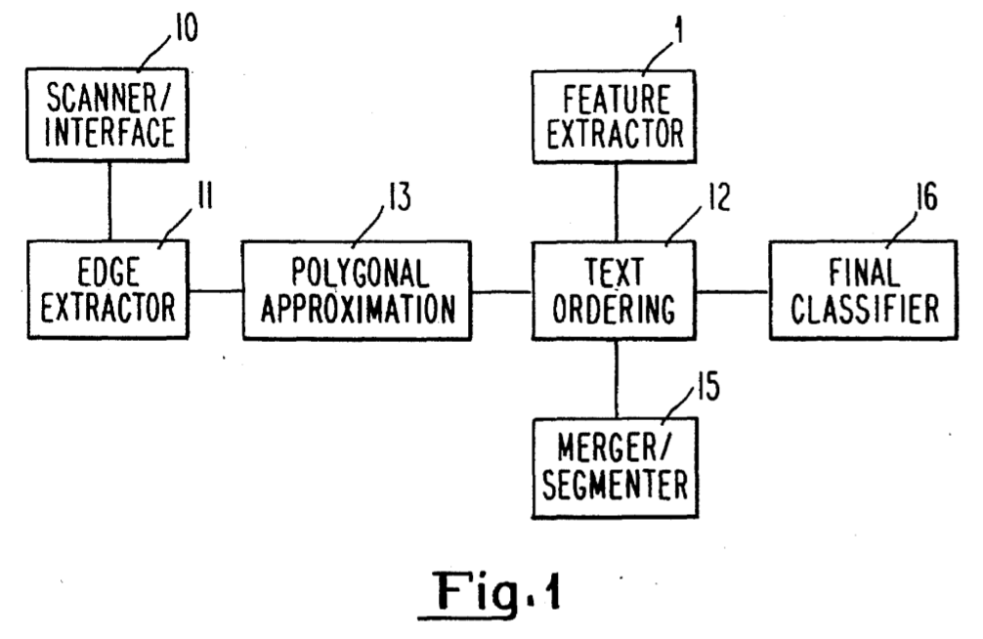

- Detailed Description

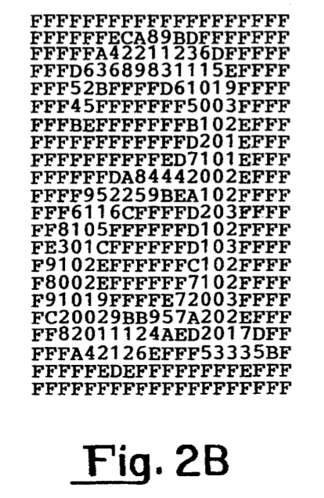
Referring to FIG. 1 an optical character recognition system comprises a scanner and scanner interface 10, an edge extractor 11, a polygonal approximation means 13, a text ordering facility 12 which operates in conjunction with a feature extractor 14 and a merger/segmenter 15 and a final classifier 16. The scanner can be any suitable commercially available device capable of producing a grey level image. One such device which can be used is a Hewlett-Packard HP9I90A scan-jet device. This device produces a 16 grey level image with a resolution of 300 pixels per inch. At this resolution each A4 page can be read in approximately 30 seconds and requires a storage capability in excess of 4 megabytes (Mbytes). This type of device makes use of a linear charge couple device array as the light sensing element and a typical grey level image for the letter "a" is shown in FIG. 2. FIG. 2A shows the image form and FIG. 2B the form of the image in hexadecimal values. In these values 0 represents black and F represents white, the values 1 to 9, A to E in between representing various levels of grey.

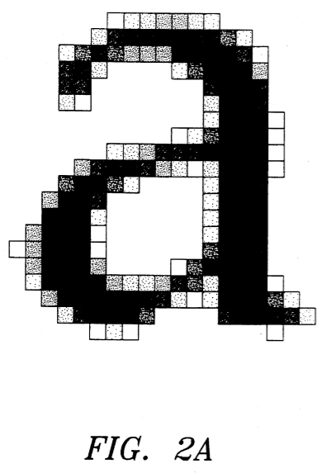

    - Scanner/Interface:
      - Explanation of how a scanner works, puts emphasis on the fact that the pages are scanned in gray scale
    - Edge Extractor:
      - Raster scans the gray level image to find edges, significant differences in gray level between neighboring pixels.
      - Uses a novel edge operator in order to locate and then follow the edge around its outline until it forms a closed loop. This operator is designed to find the edge strength perpendicular to the direction of travel between neighboring pixels. Lets say that N is the chain code direction of the next edge pixel from the current one. The edge strength of the next pixel is equal to the difference between the gray scale value at N+1 and N-1. Thus during the raster scan, the direction of travel will be left starting from the top of the image, and the pixels above and below the left one will be compared in order to determine edge strength, where the sign of the edge strength does not initially matter (could be black on white or white on black). Thus any characters found will be initially detected at their very top pixel. If the edge strength is above/below a certain threshold then the raster scan will be temporarily halted and the pixel to the left, bottom left, and bottom must be verified to have an edge of the same sign and high enough magnitude in order to ensure that the edge is significant enough before proceeding.
      - When an edge is found, it is followed all the way around until a closed loop is formed, thereby forming the outline of an object. If the edge does not form a closed loop then it is ignored. An edge tracing algorithm is utilized in order to follow the edge until it terminates or forms a closed loop. The edge tracing algorithm starts at whichever of the initially found edges has the greatest edge strength. The average of the strongest initially found edges is taken in order to determine a center value. Subsequent edges found during the tracing algorithm will be considered as “gray” if they are within a certain range of the center value and white and black if they are above or below that range respectively.
        - The tracking algorithm operates as follows. Line tracking commences by tracking left from the starting point. Given the chain code, N, or the last direction taken, edge strengths are measured at N+1, N+2, N, N-1, and N-2. We define the five or less points which have the correct sign and are above the threshold, the edge set corresponding to this position and direction. From the edge set the point with the strongest edge value is found. The choice of the next point is non-trivial, but in most cases is the point with the strongest edge value.

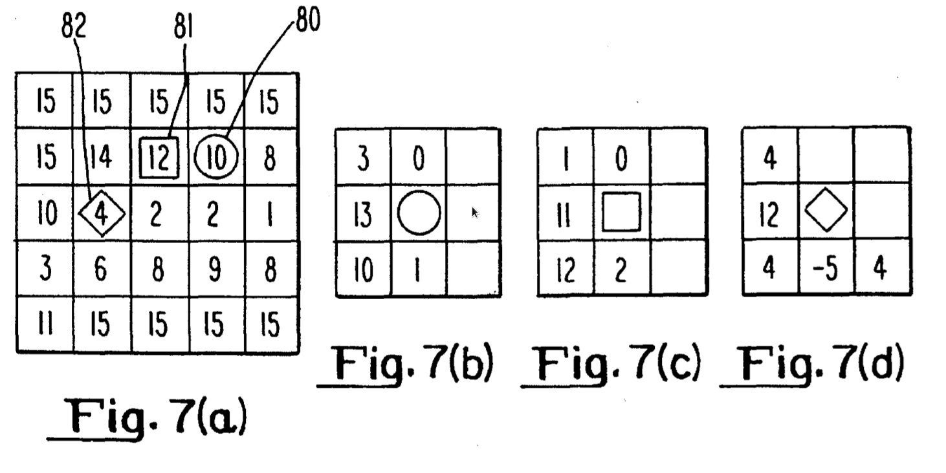

        - This is illustrated in FIG. 7 of the drawings. In FIG. 7A there is shown a 5.times.5 array of pixels and the values in each square of the array represents the actual grey level values for part the character "a" which was illustrated in FIG. 2 of the drawings. Assuming that the current point is that circled, i.e. point 80 and the last move was in direction 4 in FIG. 6, then the edge values which would be calculated at the circle 80 are shown in FIG. 7B. The next step is to the rounded square 81 corresponding to edge value 13 shown in FIG. 7B. The edge values shown in FIG. 7C are those calculated at this square. FIG. 7D demonstrates how the calculated edge values change with the last chain code and represent the edge values at the diamond 82.
        - As long as the edge following process is in progress, points on the edge path are marked current to indicate that they form part of the outline being processed. If only one point is marked at each step the raster scan will later find unused points on the same edge and attempt to follow the outline again. Therefore as many points as possible (up to a limit of three) are marked subject to the following
constraints.
          - A.) The strongest edge is always marked
          - B.) All points to be marked must be in the edge set and have edge values over the tracking threshold.
          - C.) All marked points must be adjacent.
        - Thus in FIG. 7 the points marked will be 13, 10 in FIG. 7B, 11, 12 in FIG. 7C, and 12 in FIG. 7D assuming a threshold of 4.
        - If at any time no points are found over the tracking threshold then the edge is considered to have faded, the object is discarded and the whole edge is remarked as deleted. The tracking process continues until the edge fades, a closed loop is completed, or the edge coincides with a previously completed outline. When an edge closes a satisfactory loop, all points on the loop are remarked used. The reason for changing all the marks when an edge is complete is to enable the discrimination between collisions with other lines and closing up the loop (I guess this applies to parallel processing of multiple edges and also if another line comes in contact with another closed loop to make sure that the new line combined with the prexisting loop is not mistaken for a new closed loop...).
        - FIG. 7 also illustrates that there are instances when the next step is not an obvious choice. For example at the rounded square in FIG. 7C the highest edge values are 12 and 11. In many cases the choice has an insignificant impact on the result, although this is not necessarily always the case. The choice can have an effect in the following situations:
          - A. Line cross over: In some fonts lines are of variable width. At the thinnest part of the line it may be possible to follow an edge path across the line and thus incorrectly break-up the character.
          - B. Object merger: Some characters may be printed in very close juxtaposition. At the point when the two characters almost touch, there can be a two-way decision to be made when traversing either character. Both decisions must be correct otherwise the outline of one will collide with the other, resulting in the loss of one or both characters.
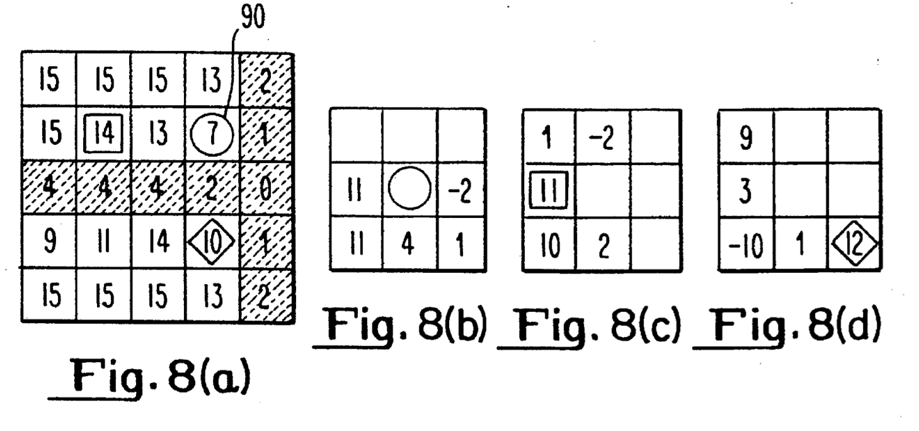
          - C. Where an edge is blurred it can be necessary to take the path corresponding to a weaker edge value nearby in order to avoid the edge from fading prematurely at a subsequent step.
        - The problems are exemplified in FIG. 8 of the drawings. FIG. 8A shows a portion of the character "a" which is illustrated in FIG. 2 of the drawings, particularly that part of the "a" at the point where the top of the loop meets the stem. The darkest pixels are shaded. FIG. 8B gives the edge values at the circled point 90, showing two points with an edge value 11. The edge sets from each of these points are shown in FIGS. 8C and 8D with the possible destinations indicated by a rounded square and a diamond in FIG. 8A. The rounded square is the correct path and the diamond is on the wrong side of the loop (what makes the rounded square the correct path??? what makes the diamond the wrong side of the loop??? Why does it matter when they will inevitably lead around the loop anyway??... look at Fig 2A, when you go around the bottom loop of the “a” from the left side of the upper right corner of the loop all the way around the loop you will come back to where you started while missing the right side of the “a”. This demonstrates incorrectly breaking up a character which is example A above).
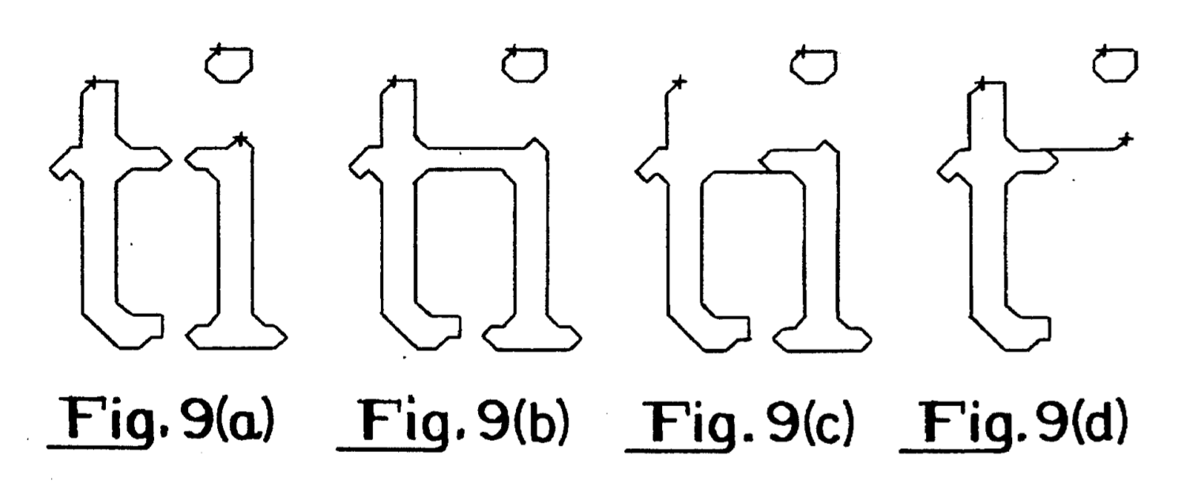
        - Problem B referred to above is illustrated in FIG. 9. FIG. 9A shows the correct outlines for a pair of closely spaced characters. The starting point for following each outline is marked with a +sign. In FIG. 9B a different choice was made while tracing the "t" resulting in a merging of the characters. The same path was followed in FIG. 9C, but with a different decision on the second path through the difficult region. The result is that the "i" is completed, but the edge did not close at the start of the loop and therefore both characters were lost. FIG. 9D shows the situation where the "t" was followed correctly, but the same route was taken for the "i" as in FIG. 90 so that it collided with the complete "t" and was deleted. A solution to this problem is to look ahead several steps to edge values beyond the current point to determine which path is to be selected.
        - Looking ahead also enables the detection of fading edges and those paths which will collide with a completed line. Alternative paths can be chosen in order to avoid problem C. A difficulty with this approach can be the amount of processing time consumed by searching a tree of possible paths to a reasonable depth.
        - There are many different algorithms for selecting the most appropriate edge path in a reasonable time and the following is a relatively simple example. It is based on the failure modes referred to above.
The algorithm for selecting between several alternative edge paths needs to be as fast as possible since there is some choice in almost every point on most outlines. The number of cases where the choice is vital however is only a fraction of the total.
The most important consideration is to avoid losing characters in the situations illustrated in FIG. 9C and 9D. Merging of characters is relatively insignificant (Maybe not for math equations however... need to find ways to avoid merging characters if they have not already been found/explored, need to look into this further).
FIG. 2 shows that there is a good dark line where the loop of the "a" meets the stem, but it is a single pixel wide. The problem characterized by FIG. 8 is due to a failing of the edge operator

A successful method of choosing between edge points is to add an amount equal to the tracking threshold to the edge value if there is a transition from "white" to "grey" or "grey" to "black", at the edge point concerned. The value is doubled if the transition is directly between "white" and "black". (where do you see more of a transition between white and black over white and grey in a grayscale document.. does it depend on the document or is there some trend here?)
A candidate edge point must have a transition in the correct direction in order for it to be considered at all. An amount equal to the difference between the grey value at the edge point and the "center value" is subtracted from the edge value. The effect of this is to direct the edge path towards the same center value as was seen at the start of the edge, and to eliminate a large proportion of false edges, which are typically caused by thin lines.
The requirement of a reasonable level of look ahead (four steps) is inevitable to prevent edges fading and collisions of the type shown in FIG. 9. In order to save time however, the edge path algorithm looks ahead down the strongest edge path only. Alternatives are considered whenever the strongest edge path fades or collides with another edge. If an edge collides with itself away from the start of the line as shown in FIG. 9C the line is not discarded. The closed part is accepted and the rest of the line is continued after back tracking to a point where there is an alternative edge path. This approach can solve many of the path selection problems referred to above.
The "center value" used during edge extraction can be thought of as a threshold. An alternative version of the edge extractor evaluates the threshold by histogram analysis of the grey levels in a local area. This is a standard technique. (see Digital Picture Processing, A. Rosenfeld, A.C. Kak, 2nd ed. vol 2. p.70-71, Academic Press 1982). The threshold is obtained by calculating the weighted means of the dip between two peaks.
The variance of the distribution of grey levels in the dip between peaks is used to calculate the tracking threshold. This operation is applied over small squares in the image to compute local thresholds.
The calculated thresholds are used as the center value in the usual edge extraction process, with the exception that the raster scan uses the value as a simple threshold, rather than searching for a strong edge.
As will be apparent from the above all edge lines are detected and traced independently, yet some edges are related. Consider for example, the inside and outside edges of a letter "o". The edges are both part of the "o" and need to be related in the output structure in order for the features to be extracted correctly. It is necessary to record that the inner edge is enclosed entirely by the outer edge.
One way of dealing with this is by a nesting tree, but this is a complex process and the following is a simpler process.
Consider the minimal upright rectangular bounding box of a closed loop C.sub.1. Let the coordinates of the bottom left hand corner of the box be (xmin1, ymin1). Similarly, let the coordinates of the top right hand corner of the box be (xmax.sub.1, ymax.sub.1 ) If the coordinates of the points on C.sub.1 are given by (x.sub.i, y.sub.i), i=I,n. then:
Clearly, given a second closed loop C.sub.2, which lies entirely with C.sub.2, the rectangular bounding box of C.sub.2 lies within the bounding box of C.sub.1, i.e. xmin.sub.1 <xmin.sub.2, xmax.sub.1 >xmax.sub.2, ymin.sub.1 <ymin.sub.2, and ymax.sub.1 >ymax.sub.2.
Given that only text is to be processed, the bounding boxes of all objects in the page are sorted using a 2-dimensional bucket sort. The bucket size is set to the minimum acceptable character size (????) so that the number of buckets in a page is considerably less than the number of pixels. As each outline is completed, it is inserted into the relevant bucket, according to the top-left corner of the bounding box. When the page is completed, a simple linear search of the buckets is used to locate all completed outlines. For each outline, the small local area of buckets covered by the bounding box is searched. Any other outlines found which are enclosed are recovered and recorded as holes in the character. (could this ever be a problem aside from with the percentage? What if you have giant rectangle with many characters inside it? Or a music staff?)
The processing time consumed by this bucket sorting procedure is minimal, since the ratio of buckets to pixels is very small, (about 1 in 256 would be adequate) yet it guarantees to find the nesting relations for all characters in the ASCII character set. There is however, one character in the ASCII set for which the bucket sort can produce incorrect results. It is possible, although highly unlikely, for the percent symbol % to be printed such that the circles appear to be enclosed by the stroke.

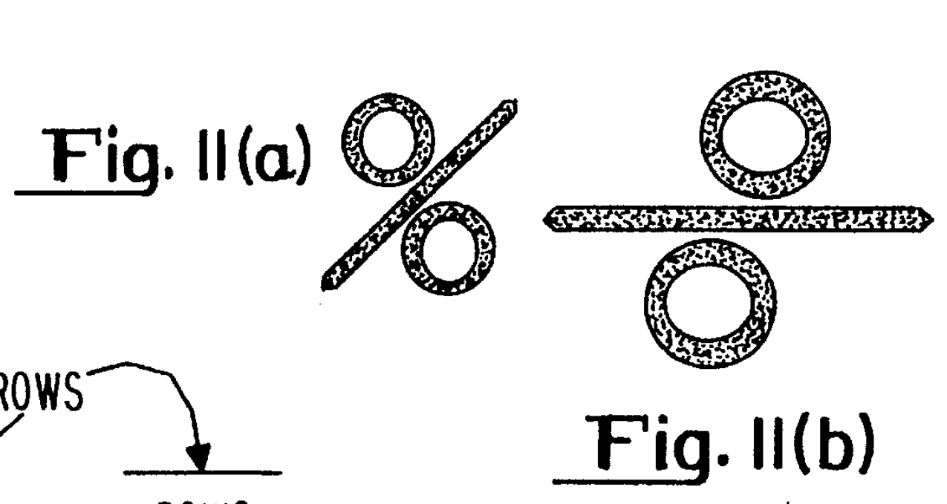

The situation is illustrated in FIG. 11a. Since this is a single exception, there is a simple solution. If the (x,y) space is transformed to the (x+y, x-y) space, and bounding boxes are also calculated for the rotated space, then testing the enclosure condition for both spaces ensures a correct result. The result of this simple rotation transformation is illustrated in FIG.11b.
Although the sole objective of the bucket sort is to obtain the nesting information of characters with holes such as 0 there is a side effect in that for a wide range of page layouts, the operation provides a successful sort of the characters into logical text order.

    - Polygonal Approximation

Detailed Description:
The output of the edge extractor 11 can be considered as an outline comprising a series of points connected by straight lines. The lines on either side of a point will either extend at 90.degree. to each other, 45.degree. to each other or be collinear. The polygonal extraction process is essentially a two-stage process. In a first stage it identifies fixed points, e.g. the point at a 90.degree. bend and identifies segments made up of two directions as shown in FIG. 13.

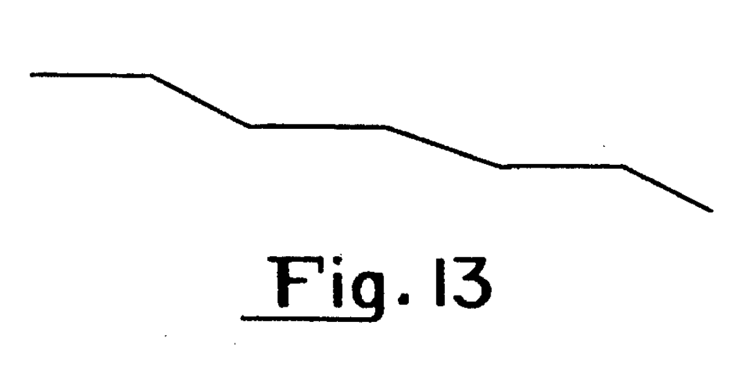
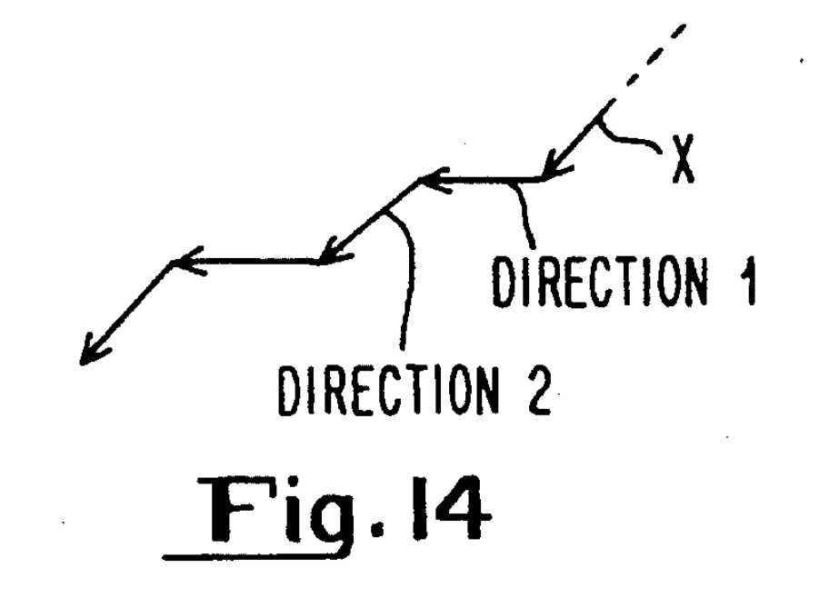
The process starts by locating either a right angle bend or a point which is the first of two 45.degree. bends in the same direction or sense. If the bend at the next point is 45.degree. the process looks forward until it finds the end of the segment. It also adds up the total length for each direction making up that segment. If the line from the start point is direction 1 (see FIG. 14) and the line from the point after the start point is direction 2 then if direction X equals direction 2 and if the length of X is greater than length 1 or the sum of all direction 2's in a segment is greater than the sum of all direction 1's the start point is moved back to point X. The next point is marked as a fixed point.
At the end of the segment, that is to say at a point from which the next direction is not direction 1 or 2 (FIG. 14), the process moves back one point from the end of the segment and if the previous point is a start point the new end point is fixed. Otherwise if the end bend is 90.degree. or the length of the last segment is greater than the length of the penultimate segment (next to last) or the sum of the total lengths in one direction is greater than the sum of the total length from the other direction then the end point is fixed as the very end point. Otherwise the end point is one point short of the end. (The point of this first step is to break the character up into segments, this describes how to find the end of each segment)
This process continues around the loop until the original start point is reached. This represents the first stage of the polygonal approximation. Before proceeding to the second stage the process identifies if there are two adjacent points which have been marked fixed and where the step in between these points has a length value 1 and the points on either side of that length not being fixed. If this situation is identified then those two fixed points are deemed to be not fixed.
In stage 2 the process proceeds around the loop initially calculating correction values for a later calculation. This is carried out on the original loop output from the edge extractor. The process counts the number of marked points (these are simply points on the outline) on either side of a main path for each section. It then takes the difference of counts (difference between what??), scales it and divides it by the number of steps. This is a correction value. The process then looks for a fixed point followed by a non-fixed point. If it cannot find any fixed point (which is unlikely) then it will arbitrarily choose one. Starting from the first located fixed point the process then identifies the next fixed point and a function approximates between fixed points. This is repeated for the remaining fixed points.
The process calculates the perpendicular distance of each intermediate point between adjacent fixed points from a point on a line joining the two fixed points. In carrying out this process it uses the correction value referred to earlier. (how??) The process sums the squares of the perpendicular distances to find the mean square deviation and the maximum perpendicular distance from the line joining the fixed points. The maximum and mean square deviations are compared against the longest side of the rectangular bounding box of the outline (so this could be either the width or height depending on which is longest...). If either exceeds a limit (what is this limit?) the two fixed points are not joined. It then recurses so that the fixed point is moved back to the point with the maximum perpendicular distance and the process is repeated until a point is found which meets the necessary criterion. The process proceeds through the loop repeating these calculations and joining up fixed points which meet the criterion to produce the polygonally approximated outline. This data is then fed to the feature extraction and merging and segmentation stage.

    - Text Ordering/Feature Extraction/ Merging and Segmentation

After edge extraction and polygonal approximation the next process is text ordering in conjunction with feature extraction and merging and segmentation. The main input to the text ordering stage 12 is a set of blob outlines and their bounding rectangles. It is significant to note that this is a different starting point to some other image segmentation systems. A functional illustration of the operation of the text ordering stage is given in FIG. 12 of the drawings.

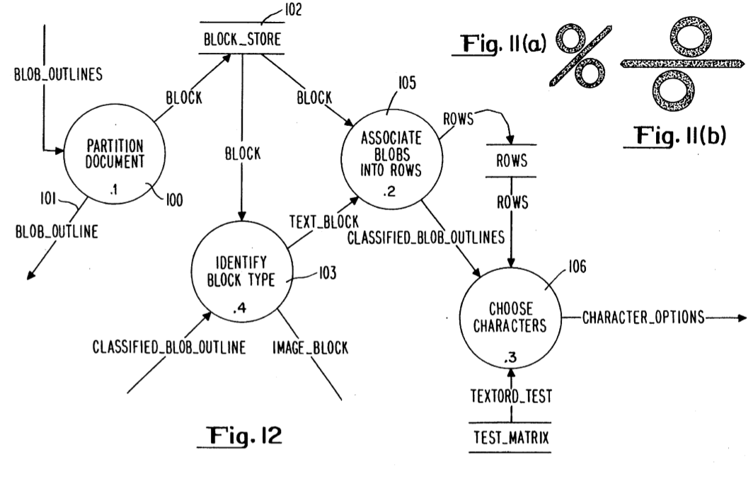

As shown, the first step in the process is to partition the document as illustrated at 100. Blob outlines are fed for feature extraction 101 and identified blocks to a block store 102 (what is a block?!!). There is an identify block type facility 103 following which the blobs are associated into rows as illustrated at 105. Finally the classified blob outlines are subjected to character selection 106. The output from this facility represents the character options for each of the blobs received from the edge extractor. Before describing the text ordering stage in more detail, the way in which features are extracted in the feature extraction facility 14 will be described. This facility extracts features from the outline polygons output from the edge extractor. Consideration of prior art arrangements shows that there are many character attributes which can be used in the processing of character outlines. For the present arrangement we have selected a set of 5 functional attributes which are set out as follows in order of decreasing importance for character recognition:
1. Concavity. Concavity is defined as any concave part of an outline. This includes concavities known as bay, inlet, notch and hook together with small concavities which result from crossing, weld and marker.
2. Closure. By this is intended to mean functional closure as defined, for example, by Shillman R. in his phD thesis 1974, entitled "Character Recognition Based on Phenomenological Attributes: Theory and Methods", a paper in International Journal of Man-Machine Studies Vol. 6, No. 6, P.701-714.
3. Line. A line is a straight part of the outline which results from a shaft, arm or leg.
4. Axis. An axis is defined only for characters which do not have concavity or a closure. The axis indicates the direction of the major axis of the object and measures the ratio of the length of the major and minor axes. It can be used to resolve ambiguities within the ASCII character set which are not covered by Shillman's attributes. An example is the resolution of an ambiguity between a dot and a straight quote or comma.
5. Symmetry. Symmetry can be measured in either a vertical or a horizontal axis.
The following is a description of how the features referred to above are extracted from the polygonal outline approximation supplied by the edge extractor and the way in which each is numerically represented. Before describing the extraction of each feature in detail, the concise notation for the points and vectors on the outline is set out below.
The object to be recognized consists of one or more closed loops, formed by a total of n points with integer coordinates. If the n points are connected in sequence by straight line segments, and the last point is joined back to the first, then a left oriented closed loop is formed; i.e. the interior of the character is always on the left when moving from a point to its successor. Thus, the outside loop is stored in anticlockwise sequence and holes are stored in clockwise sequence.
Pi is the coordinate pair (xi,yi) of the ith point.
Pi+1 represents the coordinate of the successor point to Pi. Note that this is the next point around the closed loop containing Pi and not necessarily the (i+1)th point.
Pi-1 similarly is the predecessor point to Pi.
PiPj is a vector from the point Pj to the point Pi.
Pi and Pj may be on different closed loops.
Pi+ is an abbreviation for PiPi+1.
Pi- is an abbreviation for PiPi-1.
a . b= axbx+ ayby is a scalar product of two vectors.
a x b= axby - aybx is a cross product of two vectors. The result is a scalar value.
Pi is convex if Pi+ x Pi->=0, otherwise it is concave.
¦PiPj¦² = PiPj . PiPj = (xj - xi)² + (yj - yi)² is the squared Euclidean length of the vector PiPj, i. e. the distance between Pi and Pj. In this specification, the terms distance², length² etc will refer to this measure.
¦PiPj¦ is the square root of ¦PiPj¦².

A concavity is a part of the outline which does not lie on the convex hull of the outline points. For each set of points which do not lie on the convex hull of the outline (smallest convex region enclosing it), one or more concavities is generated.
A concavity is split if it contains a convex point which is a local minimum in terms of perpendicular distance away from the hull line. (the hull line is the part of the convex hull with which the outline is not coincident -overlapping). The depth of the concavity on either side of the minimum must be a significant fraction of the depth to the minimum point for the split to take place.
In the case of a split, the two parts are treated exactly as if they were ordinary concavities, except that the direction will be that of the original hull line. FIG. 15(a) shows a concavity with a split.

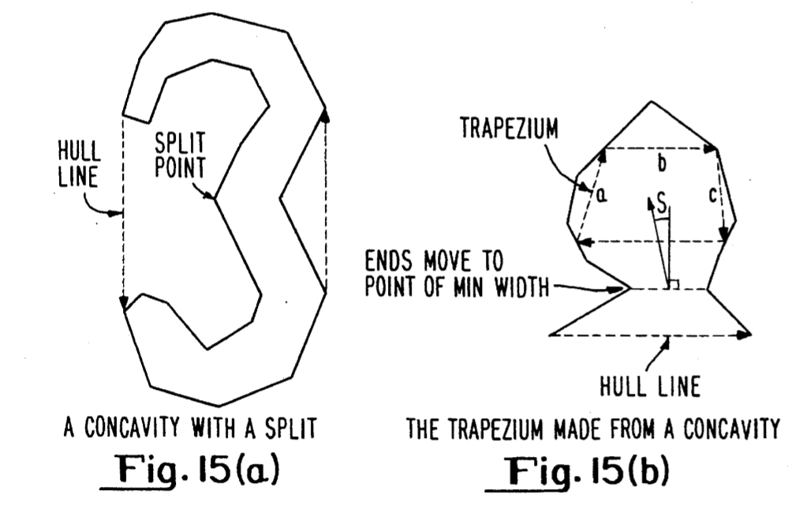

A concavity may also form a closure if the width of the narrowest part is extremely small when compared with the width of the widest part.
Once the concavity has been identified to contain no more splits, if it has a local minimum width less than half way in, the ends (what ends???) are moved in to the narrowest point. See FIG. 15(b). I really don't understand how to relate 15b to 15a.... maybe they aren't even supposed to be related... that would be my guess...
A trapezium is then formed by drawing lines, parallel to the hull line (which hull line, what if there is more than one???), across the concavity at 1/4 and 3/4 of its depth. FIG.15(b) shows the trapezium. The trapezium is used to generate several of the numerical components of a concavity:
- (a) The direction of a concavity is the direction of the hull line (when it was first located) quantized to the range [0,63].
- (b) The position of the centroid of the concavity, after the ends were moved in the narrowest part. The coordinates are normalised independently to the range [0,63] relative to the minimal upright rectangular bounding box of the outline, so that (63, 63) represents the top right corner of the bounding box.
- (c) The shape of the concavity is given by:

where a, b, c are as shown in Figure 15(b). The result is clipped to [0,63]. This gives a measure of angle between the sides of the trapezium.
- (d) The depth of the concavity is given by the perpendicular depth of the trapezium divided by the length of the base. (The line nearest the hull line). The result is multipled by 32 and clipped to [0,63].
- (e)The skew of a concavity is given by the angle between the line drawn from the centre of the line across the end of the concavity, to the centroid of the concavity, and the line perpendicular to the line across the ends of the concavity. This angle is marked S on Figure 15(b). The angle is quantised to the range [0,63] by mapping 0 to 32, -pi to 0 and pi to 63.
- (f)The area of the concavity as a fraction of the area of the convex hull, scaled to the range [0,63].

Turning now to closures, a closure is generated for each physical closure. As each concavity is generated, it is tested for functional closure. A known functional closure definition can be seen by reference to FIG. 16. For circular characters with a gap at the top, as in FIG. 16(a) the rule is given by:

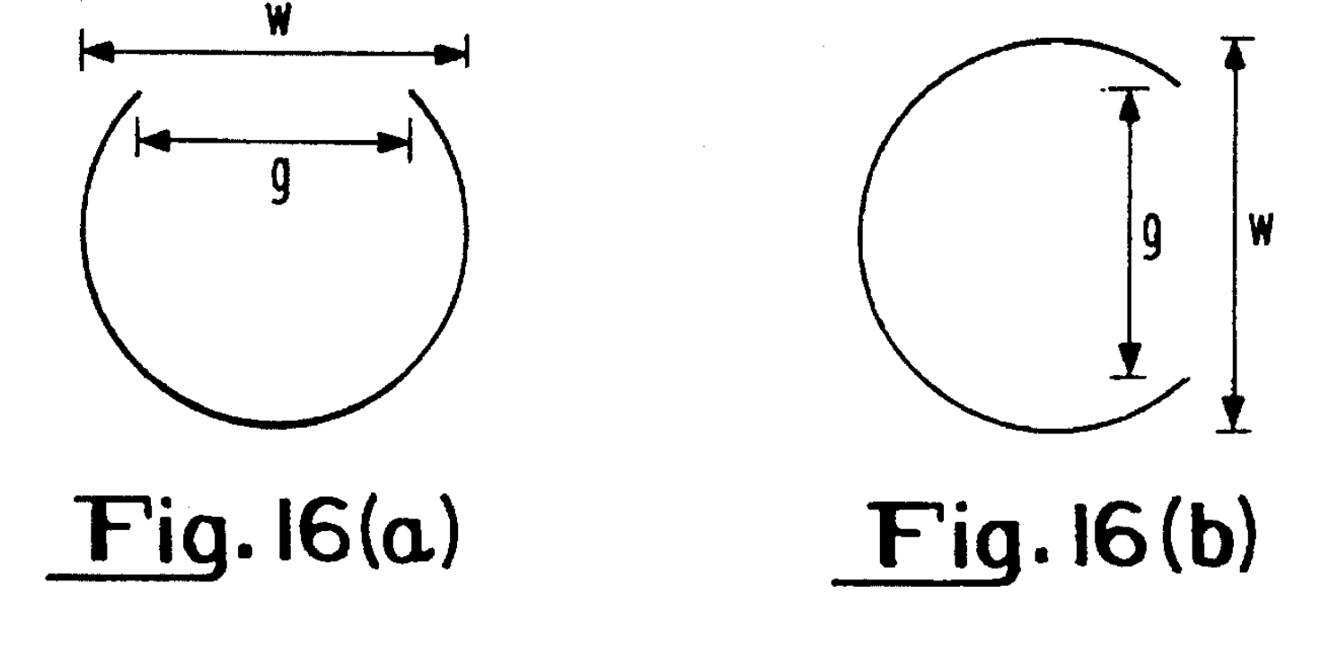

The gap is functionally closed if g/w<0.56
If the ambiguity is between "O" and "C" i.e. the gap is centered at the right, as in FIG. 16(b) the rule becomes:
The gap is functionally closed if g/w<0.23.
The test depends on the direction. For a right-facing concavity, experimentation has revealed that the threshold value given above is too large. In order to prevent certain occurrences of "G" from being functionally closed, the threshold has been reduced from g/w=0.23 to g/w 0.17, where g = ¦PiPj¦ and w is the maximum width of the concavity in the same direction as PiPj.
Different values are used for other directions. For a downward or left facing concavity, the threshold is currently set at 0.29. For an upward facing concavity, the threshold is set at 0.38. For all directions, an additional constraint is added:

where d is the depth of the concavity as described above, and A is the area of the concavity. This constraint effectively reduces the g/w threshold for deep concavities, making it less likely that characters such as "e" are closed.
The following values form the numerical representation of a closure:
- (a)The normalised relative coordinates of the centroid of the closed region. The calculation of the coordinates of the centroid is identical to the method used for concavities and is described below.
- (b)The scaled area of the closure as a fraction of the area of the rectangular bounding box of the character. The fraction is scaled to the usual [0,63] range.
The axis feature is generated only if the character has no concavity or closure. Rather than perform a squared order calculation to find the greatest distance between any pair of outline points, a linear algorithm is used.
Firstly, the centroid C of the object is calculated. The point Pi on the outline is found such that ¦PiC¦² is a maximum. The maximum perpendicular distance of any point on the outline from the line PiC is calculated independently for each side of the line. The results are summed to give the width of the object. Figure 17(a) illustrates how the width of the object is calculated.
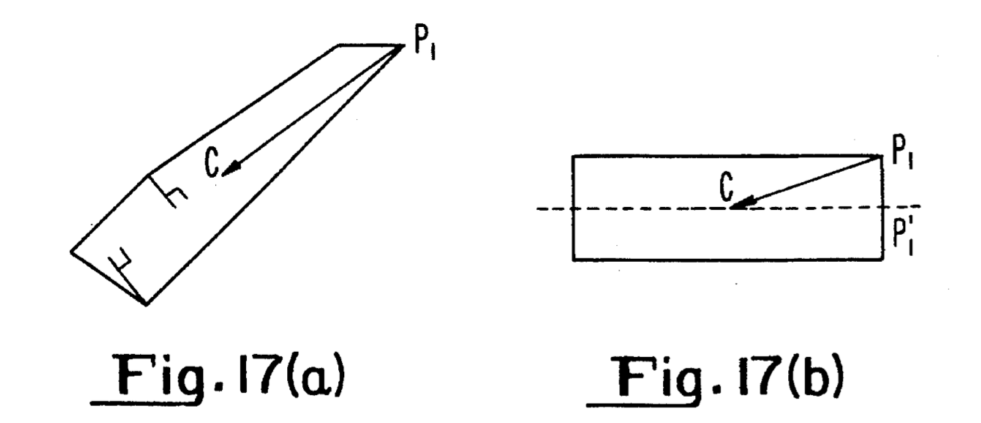

The direction of the major axis of the object is given by the vector PiC, unless a smaller width result is obtained by moving Pi to the midpoint of Pi+ or the midpoint of Pi-. Moving Pi to one of the adjacent midpoints provides an adjustment of the direction in the case of the object in Figure 17(b), where the new position of Pi is shown as Pi′.
Having established the direction of the major axis, the length is obtained by applying the same width calculation to a vector perpendicular to PiC.
The numerical representation of an axis consists of the following items:
- (a)The ratio of the width of the object to the length of the major axis.
- (b) The direction of the major axis is quantized to the [0,63] range. Unlike the other features which include a direction, the axis has no sense (???). Therefore it may differ by 32 units (modulo 64) from another in the same direction.
The direction is clearly meaningless when the width to length ratio is high, (i.e. close to 1,) since a dot, for instance, can have no direction.
Lines are used only when an unknown character closely matches two of the standard templates, as measured with concavities, closures and axes. In the detection of lines there is a trade-off between reliably locating all useful lines and finding false lines in approximations to curves.
A line is defined to consist of one or more segments of the polygonal approximation which satisfy a minimum length condition. If the line consists of more than one segment, the maximum perpendicular deviation of any point along the line, from the straight line joining the ends, must be below a certain limit.
The conditions serve to reject lines which are part of a curve. FIG. 18(a) illustrates some examples of possible lines which do not meet all the criteria. The bold parts of the outline in FIG. 18(b) indicate accepted lines. A line is identified by the following numerical values:

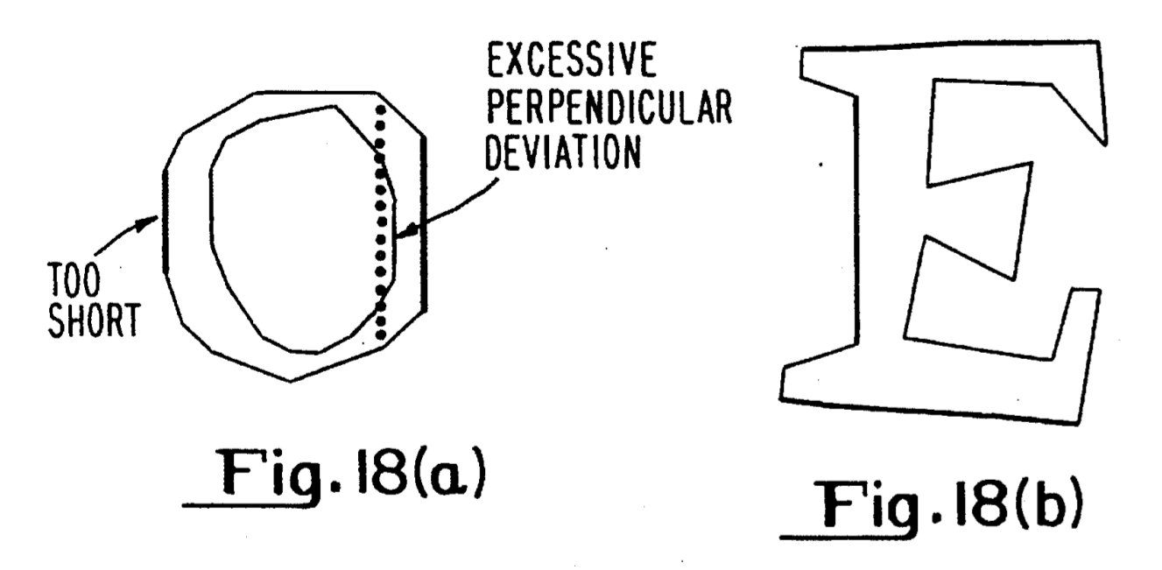

- (a) The normalised relative position of the centre of the line.
- (b) The quantized direction of the line.
- (c) The scaled length of the line as a fraction of the maximum size of the rectangular bounding box.

Symmetry is a useful measure, for discrimination of the following pairs of characters: C/G, j/), j/], T/1, ]/7, B/8, O/D. The main difficulty is to locate the axis of symmetry. For vertical text, the axis is simply a vertical line through the center of the upright bounding box of the character. For italic text however, the axis is rotated slightly and the exact position is difficult to locate, especially with characters such as "0".
The axis of symmetry is calculated by two methods. If the first fails to produce a result, the second method is used. The second method will always produce some result.
(a) The first method searches the outline for a vector which passes from the bottom half to the top half of the bounding box. If the vector can be extended around the outline to span half the height of the bounding box, equally about the center, without going through a significant change in direction, then the summed vector is added to the result.(what is the result????)
If any such vectors are found, then their sum gives the direction of the axis of symmetry. This method is successful for round characters, such as "0" and "e", and for characters containing vertical lines, such as "H", "p" etc. It does not produce a result for angular characters such as "X" or "8". (what result is it supposed to produce?????)
(b) The second method finds the rightmost point on the outline, and finds the most clockwise line which can be drawn through this point, without intersecting any other part of the outline. The same operation is performed with the leftmost point on the outline. The line which was least clockwise from vertical becomes the axis of symmetry.
Both vertical and horizontal symmetry can be used in the recognition process. Vertical symmetry is measured by consideration of each point Pi on the outline. If the axis is not vertical, the coordinates of Pi are transformed back from the sheared coordinates to rectangular coordinates. The least distance² between the reflection of Pi in the axis and the transformed outline is measured. A measure of the vertical symmetry is given by the maximum such distance for all points on the outline.

Horizontal symmetry is measured similarly using a horizontal axis. The same transformed outline as was constructed for measurement of vertical symmetry is used. FIG. 19(a) illustrates the outermost outline of an italic "B". In FIG. 19(b), the outline has been inverse sheared back to the vertical, and the reflected points are shown as joined by dotted lines. Some of the "+" marks are clearly a significant distance from any part of the solid outline.

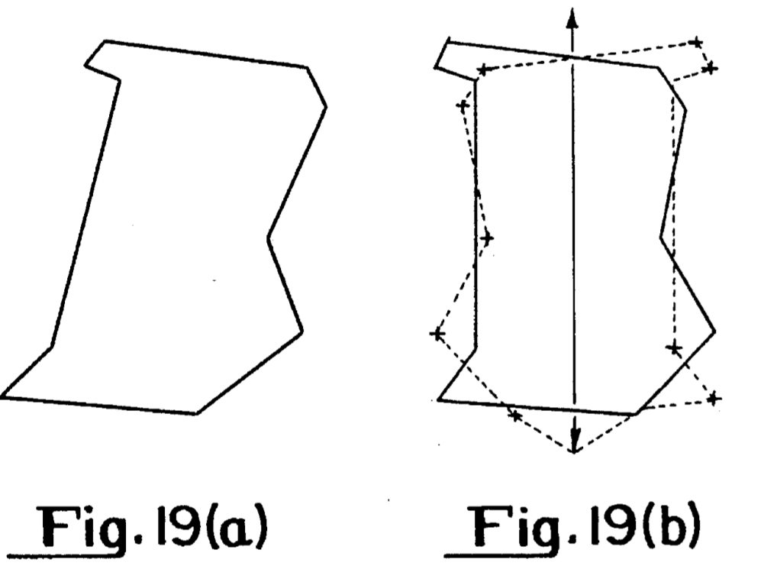

Symmetry is tested by commencing at a point where the axis intersects the outline and working in opposite directions simultaneously. If the object is to be at all symmetric, then the point nearest a reflected point must be in the locality of the current point on the opposite side of the object.
Measurement of symmetry is applied only in the case of an unknown character matching a particular pair of templates. Only a single direction will be measured in most cases, according to the pair in question. The result is a distance which is squared and must be scaled to a fraction of some measure of the size of the object, for instance, the area of the rectangular bounding box.
A second measure of symmetry is calculated by computing a vector from the center of the de-sheared bounding box, to the centroid of the de-sheared outline.
The numerical representation of this symmetry measure is composed of the individual components of the vector as a fraction of the size of the de-sheared bounding box, multiplied by 128 and clipped to [-32,31].
The following illustrates the calculation of area and centroid.
A simple procedure is used to simultaneously calculate the area and centroid of a closed region. In Figure 20, there is a closed region bounded by a polygonal approximation of n points, P₀,P₁,. . . Pn-1. The closed region is divided into n-2 triangles, T₁,T₂,. . . Tn-2. Let the triangle Ti be bounded by the points P₀PiPi-1.

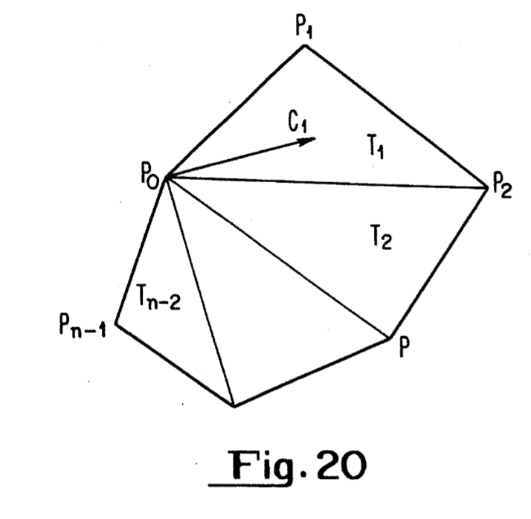
Then the area of Ai of triangle Ti is given by:
A₁ = (P₀Pi-1 x P₀Pi)/2
Let the vector From P to the centroid of Ti be ci. Then
ci = (P₀Pi + P₀Pi+1)/3.
The vector from P₀ to the centroid of the entire region is given by:

It can be shown that the above formulae for the total area and centroid are not affected by the object being concave, since the cross product yields negative results where necessary.
The different types of features described above are regarded as being totally separate and therefore adjacency relations between a concavity and a line, for instance, are not recorded. This separation simplifies the recognition process and has been experimentally determined to actually improve recognition accuracy. There are two reasons by complex adjacency information reduces rather than increases the recognition rate:
- (a) Simple positional information is adequate for uniqueness in the ASCII character set (is this true for math as well???). As an example, it is difficult to construct an outline which contains a closure at the top, a downwards facing concavity at the bottom and oblique strokes at the right and left without producing an "A". Removal of the adjacency information therefore does not reduce accuracy.
- (b) A line may be located within a concavity. Occasionally, one end of the line may extend beyond the limits of the concavity, thus changing the apparent ordering of the features. Using the adjacency information can therefore reduce accuracy.
Multiple occurrences of the same type of feature however, are ordered, since this also simplifies comparison. The features of each individual type are recorded in the order in which they are located on the outline. This necessitates a reliable definition of origin.
An obvious solution is to maximize a function of the coordinates of a point taken over all the outline. The function must be reasonably simple to calculate, and yet the contours must be such that no character has two distant points on the maximum contour. As a simple example, consider the function f(x,y)=y-x, which selects the top left corner of the object. The character "+" however, has two distant points which lie on the maximal contour of f (x,y). Slight variations in size or aspect ratio may result in a dramatic shift in the location of the origin, which would cause different representations of the same character.
The problem is exemplified by FIG. 21. The dotted line 110 indicates the maximum value of f(x,y)=y,x in each case. The "+" in FIG. 21(a) has its origin at the top, whereas the in FIG. 21(b) has its origin at the left. The present function for selecting the origin is f(x,y)=4y-x. This function was chosen to allow a reasonable skew of the page, while selecting a reliable point on every ASCII character with the possible exception of "*".
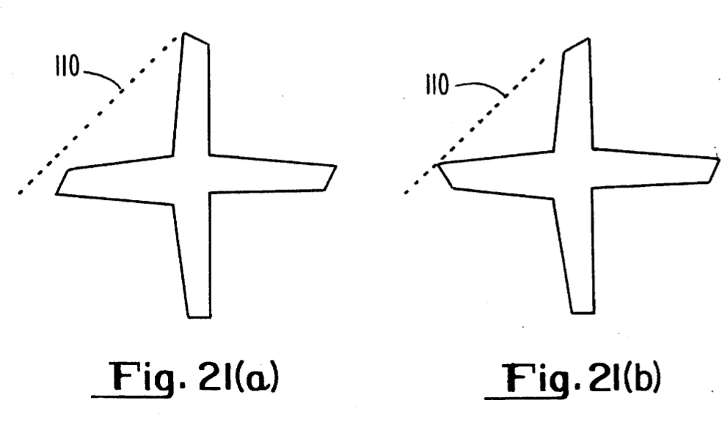
As can be seen from the functional representation given in FIG. 22 the system requires a set of standard templates with which to compare an unknown character. The most appropriate way to generate the templates is by analysis of samples covering a wide range of fonts. It is intended that the completed system will recognize a very wide range of printed fonts without any training or intervention from the user. The learning process must therefore, provide a sufficiently wide range of fonts such that no further training is required.

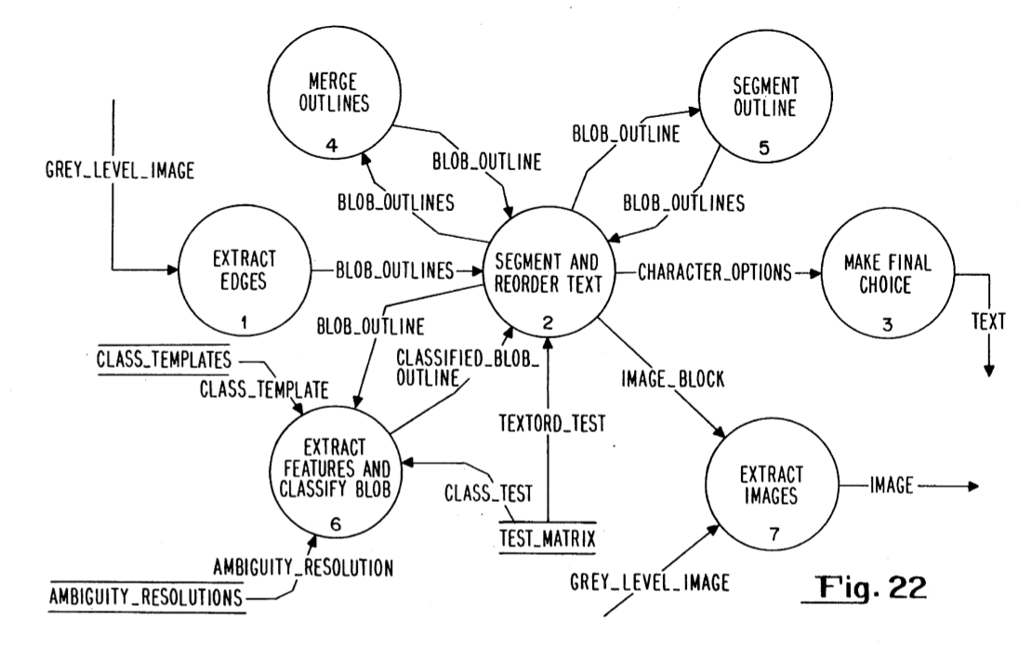

The learning process involves generating the features for a set of character outlines with known ASCII codes. Several samples of each character in as wide a range of fonts as possible must be supplied, so as to learn the expected variation in the numerical representation of each feature.
The result of the learning process is a set of character classes. A character class represents a set of one or more characters which have an indistinguishable set of features. An example of a pair of characters which occupy the same class is C/c, where the only difference is one of size relative to neighboring characters.
Conversely, one ASCII character may appear in several different guises, such as a/a. A more subtle variation occurs in punctuation marks. The comma, which appears as the same shape in a semi-colon, quote and double quote, has two fundamentally different shapes: straight as in ' and curly as in .cndot.. Two different classes will result, each of which contains all the aforenamed characters.
In order to construct the standard templates automatically, it is necessary to detect the differences between two versions of the same character, and similarities between different characters. The process therefore includes the following steps:
- (a) Clustering. All the similar features from different samples of the same character are grouped together into clusters. The extreme feature values within each cluster give the limits on the acceptance range. The number of samples which contribute to a cluster indicates the importance of the corresponding feature in recognition.
- (b) Partitioning of classes. Those classes which do not have a minimum number of consistent features, i. e. those for which a cluster is generated by all samples, are partitioned.
- (c) Merging of ambiguities. Ambiguous classes are merged where there is some physical distinction between the characters which can be used at a later stage to distinguish them.

A functional representation of the generation of templates is given in FIG. 24.
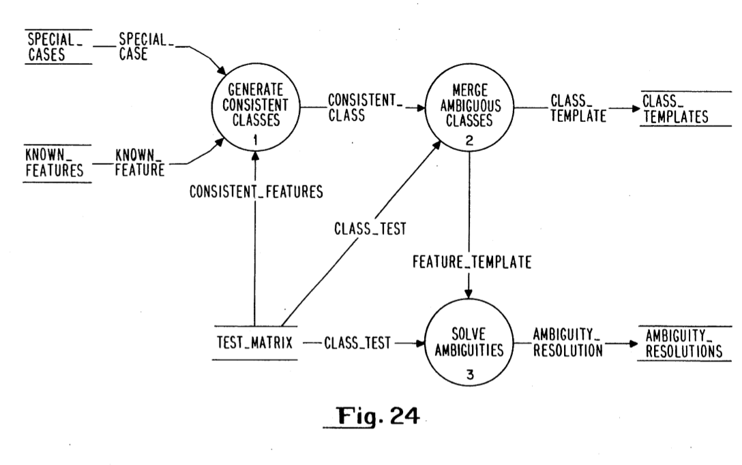
A standard clustering algorithm can be used to detect similar features in different samples of the same character. The nature of the data however, simplifies the clustering problem.
A sample character may have several features of the same type, each of which must lie in a separate cluster. If most samples of the same character contain largely the same features, as is the case if the class is not to be partitioned, then it is reasonably simple to match corresponding features and create new clusters for those which do not match.
The clustering algorithm copies the first sample character to the standard template. Each subsequent sample of the same character is compared with the standard template using a flexible matching algorithm. In the comparison, only the most important numerical values are considered, for instance the position and direction of a concavity. A much greater tolerance of error is also included. For features which match a feature in the standard template, the acceptance limits are expanded. Those features which do not have a match in the standard template are inserted in the relevant position, using the order from the origin.
FIG. 25(a) shows an example of the first sample of a letter "H". The square indicates the limits of the standard [0,63] range on the (x,y) coordinates of the centroid of the concavities. The marks indicate the positions of the two concavities in the first sample. FIG. 25(b) shows the final template for the concavities after a total of 7 samples have been analyzed. The clusters on the left and right of the square are caused by serifs on the top and bottom of the "H". A dotted "H" is superimposed on FIG. 25(b) to show the relation between the character and the concavities.

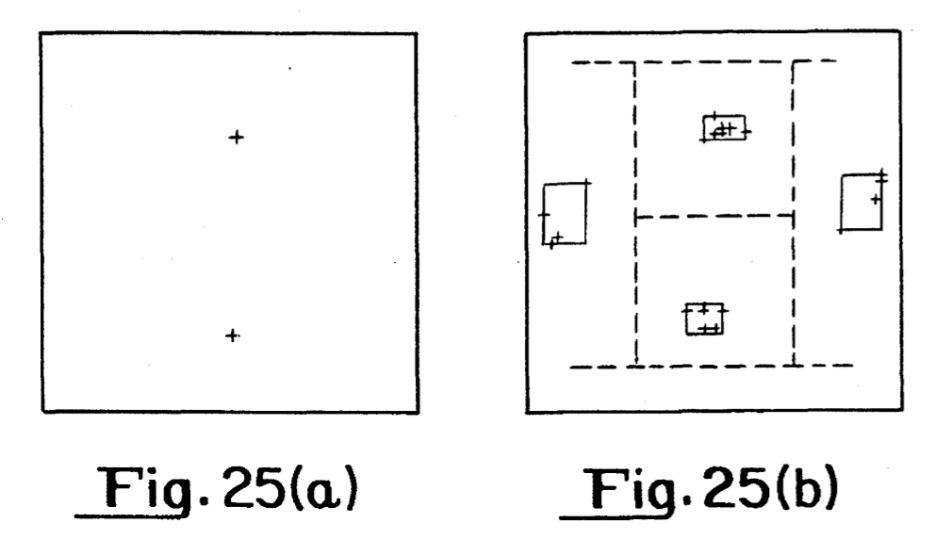
A consistent feature is one which exists in all the sample characters which were used to construct a template. When all the samples of a character have been read and compacted by the clustering algorithm, a count is made of the consistent features. If the number is below a set limit, the class is partitioned. The limit is set individually for each character in a database.
Partitioning is based on the modal feature (most frequent). All samples which possess the modal feature are placed in one partition, and the remainder go in another. If the minimum number of consistent features for the character is two, then only those samples which possesses the two most common features are placed in the first partition.
If the second partition does not contain the required number of consistent features, then that is sub-divided until all partitions satisfy the minimum consistent feature criterion. A partition can fail to satisfy the minimum consistent feature criterion if it contains a sample with less features than the minimum. There must clearly be an exception to the rule, to allow a partition to contain too few consistent features if there is no feature which is not consistent.
The less ambiguity that exists between the final templates, the higher the accuracy of the final classification. In order to obtain a low ambiguity level, it is inevitable that some classes must contain more than one ASCII character. Merging is acceptable only if the characters can be distinguished by some physical measure which is unavailable at the feature extraction stage. Examples of such measurements are:
- (a) Relative height. Used to distinguish capital and lower case letters.
- (b) Position on the text line. Pairs such as ,/' and -/_ can only be discriminated by position on the line.
- (c) Neighbouring marks. The set { !, ", %, =, ;, :, ?, i, j } are all distinguished from other characters by the presence of neighbouring marks. These characters result in several classes, each containing a different set of characters.
- (d) Context. Certain characters appear identical in some fonts. The usual problem sets are {O, 0} and (l, 1, I}. The only guaranteed way to determine the correct character is by context. The classes can therefore be merged. Certain other pairs such as {S, 5} are difficult but not impossible to distinguish. Context will be helpful in making the correct decision in these cases, but it is not acceptable to merge the classes.

In order to automatically merge the correct characters into a reasonable set of standard templates, use is made of a knowledge base. The knowledge base consists of a list of characters which may be merged with each character in the character set. Generated manually?
When the final classes have been determined, a weight is assigned to each feature within each class. The weight determines the matching error which will be generated if the feature is absent in an unknown character.
The ideal way to generate the weights would be to try all reasonable combinations of values to minimize the ambiguity across the entire character set. This is obviously impractical, due to the enormous number of combinations of reasonable values. It would be possible however, to use an iterative evolutionary process to refine the weights randomly and maximize the distance between different classes. Such a process would identify those features which are important in distinguishing almost ambiguous characters, such as the closure in the pair {*,#).
The present algorithm for assigning weights to features is simple but effective. For consistent features, the weight is inversely proportional to the number of consistent features in the class. A "C" therefore, with a single consistent feature, will have a high weight for the concavity. Conversely, "#" will have a low weight for each feature, since loss of any one, apart from the closure, is relatively insignificant and common. Features which occur in more than 75% of the samples have weights assigned similarly, but with a lower constant of proportionality. All remaining features are considered embellishments and are assigned zero weight.
Once the features have been extracted from an unknown character, an attempt is made to match the features against one of the standard class templates. One of the most important aspects of the recognition process is that it must be flexible. Different fonts cause variations in the features that are detected. It must be possible therefore to recognize a character which has one or two additional features or missing features.
Simultaneously, it is desirable to test the unknown character against as few templates as possible, in order to increase the recognition speed. Speed and flexibility are, to some extent, mutually exclusive.
Flexible comparison is carried out as follows. Each individual type of feature is considered separately. For each type however, the features are ordered in the sequence in which they occur from the origin. The comparison task therefore is to match two ordered lists, each of which may contain elements which do not occur in the other. FIG. 26 illustrates the result of the flexible matching process. A list of test features is to be matched against the list of standard features .
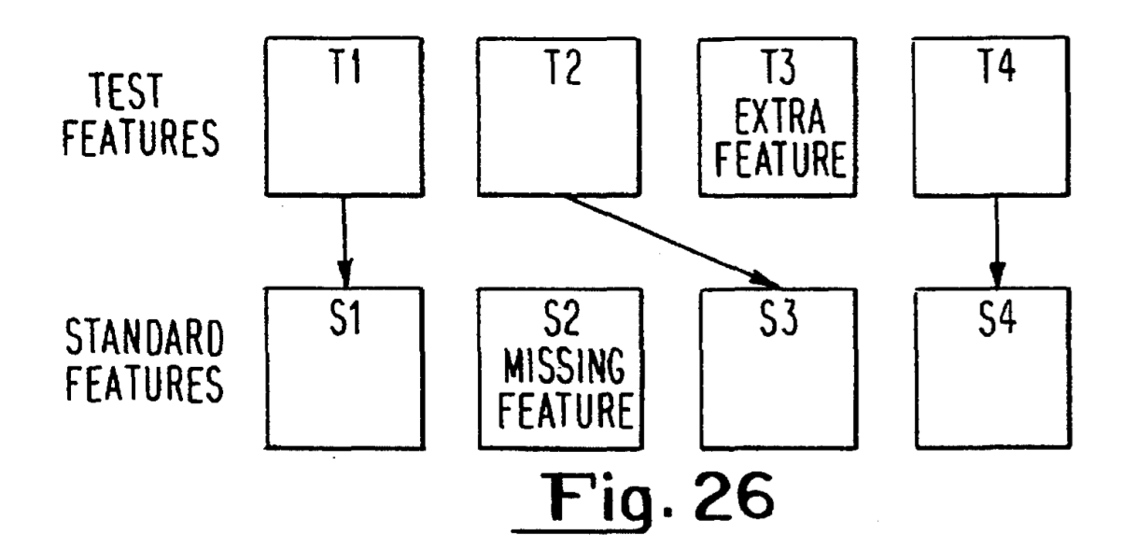

A match error is generated for the entire list, which is the sum of individual match errors between the features connected by arrows, and errors generated for the missing and additional features.
A direct comparison between two single features involves testing all the elements of the numerical representation of the feature. Consider for example, a closure. Let the limits on the x-coordinate of the centroid of the closure be Xmin and Xmax. If the x-coordinate of the centroid of the closure in the test feature is X, then a match error, e, is generated as follows:

e = | ¦ X - {Xmin + Xmax)/2¦ | If Xmin <= X <= Xmax
 | W (Xmin - X) | If Xmin-d < X < Xmin
 | W (X - Xmax) | If Xmax < X < Xmax+d
 | Wd | If X >= Xmax+d or X <= Xmin-d

where d is a maximum allowed deviation from the acceptance range, and W is a weight. W is derived from Xmax - Xmin and Mmax.
The match errors for all the elements of the feature are summed, with weights on each element. If the total is greater than Mmax, it is set to Mmax. This ensures that all failed matches have the same value, whatever the type of the feature. Let the match error between a test feature Ti and a standard feature Si be denoted by M(Ti,Si).
With this approach, values which are well outside the acceptance range produce a fixed maximum error, rather than an infinite error. The fixed maximum provides flexibility by still allowing a match when small parts of a limited number of features are out of range.
If the value is within the acceptance range, then a small match error is generated, rather than zero, indicating the distance from the center of the range. This small error is to provide some difference between intrinsically ambiguous characters such as "u" and "v" where otherwise a character may have a match error of zero for both classes.
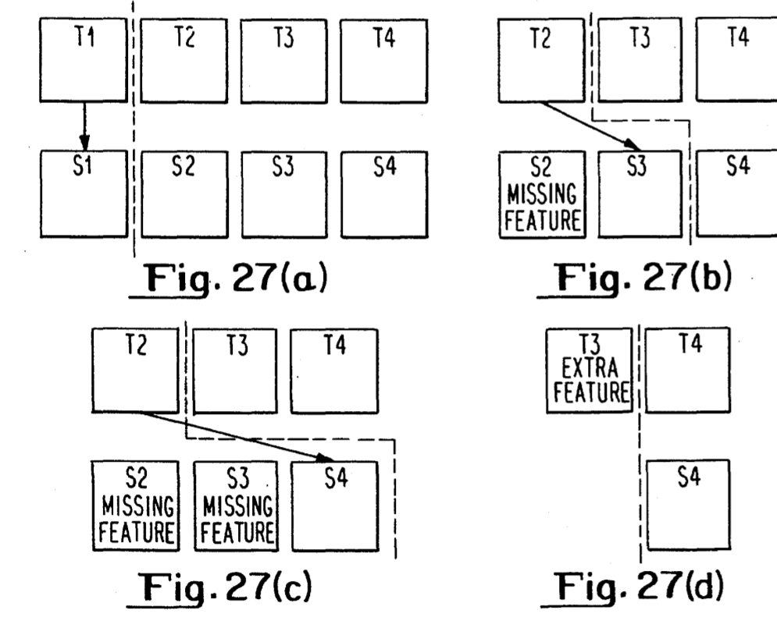
A recursive procedure finds the best match between two ordered lists of features by performing a depth-first search of the tree of all possible ordered matches. The first operation is illustrated in FIG. 27. If:
M(T₁,S₁) < Mmax
then the match rating for the entire string is equal to M(T₁,S₁) plus the best match rating for the remainder of the lists, generated by recursion. The first test feature is then matched against each of the remaining standard features in turn, summing the errors for each skipped standard feature. This process is illustrated at the second level of recursion by Figure 27(b) where S₂ has been skipped and T₂ is matched against S₃, and in Figure 27(c) where both S₂ and S₃ have been skipped. The error generated for skipping S₂ is governed by its weight. Note that recursion only occurs when there is a match less than Mmax.

The final operation is to assume that the first test feature is an extra feature. This is skipped, generating a fixed level of error, and recursion is used to evaluate the match rating of the rest of the list. FIG. 27(d) illustrates skipping the first test feature at the third level of recursion. ????
The match rating for the list is defined to be the lowest result obtained from the depth-first search. An obvious reduction in match time is obtained by truncating the search where the accumulated error exceeds the lowest full depth error so far.
The algorithm for matching an unknown character against a standard template is described above. Testing each character against the entire set of templates would guarantee that all possible matches are detected. The time involved however, is unacceptably great. It is therefore necessary to reduce the number of standard templates tested, while ensuring that the correct match will be obtained.
The method adopted is to use a look-up table to select a small subset of the full character set. Each feature of a test character is used to locate those standard classes which include the same features.
For every possible x-coordinate in the usual [0,63] range, a bit array is constructed, with one bit per character class. The bit for a class is set if the class has one or more concavities which include the x-coordinate in their acceptance ranges. The acceptance range in this respect includes the maximum error allowance, d, made during comparison of two features.
A similar array of bit arrays is constructed for the possible y-coordinates and directions of a concavity (this the third bit array??). The concavities of an unknown character will be used to look-up bit arrays corresponding to the position and direction of the concavity. The three arrays are then logically ANDed (processed through an AND gate), resulting in an array of bits indicating all the classes which will accept the concavity.
A similar operation on all the other features of the unknown character results in a set of bit arrays, one for each feature. (So each feature consists of an array of 64 bit arrays???)The arrays are used to construct a single array, which gives the number of ones in each bit position. If the unknown character has features, and it is a perfect match with one of the standard templates, then the highest bit count will be n, in the position of the matching class. Comparison of the unknown character against all the classes which have a bit count of n will guarantee to find the correct class.
If the unknown character is not a perfect match to the relevant template, then it may have one or more extra features and/or missing features. Missing features will still result in a perfect response with the correct class, but an increased number of other classes will also give a perfect response, resulting in an increased search time.
If sufficient extra features are present, then it is possible that the correct template will not even be tested, since some other class may have more matching features, yielding a higher bit count. In this case, the correct class can still be found by reducing the target bit count when no classes are found with a sufficiently low match error.
Thus the look-up tables can be used to obtain a significant reduction in the number of templates which need to be compared with an unknown character, without any danger of missing the correct class. The typical reduction obtained in practice is of the order of 80-85%. This figure would be considerably higher if there were fewer classes which have only one significant feature, i.e. when symmetry is added.
To summarize the feature extraction facility uses a set of five features which is adequate for recognition of the entire ASCII character set. These features are: concavity, closure, line, axis and symmetry. Each of the above features can be detected in a time linearly related to the number of outline points in a character. The need to perform any kind of thinning operation is thus completely eliminated.
A training set of characters is used to produce the standard templates by a split and merge procedure. Firstly, classes are split where the same character has disjoint sets of features, such as with "a" and "a". Ambiguous characters are then merged into single classes where a simple operation may be used to distinguish them at a later stage of processing.
A flexible matching process is used to match unknown characters to class templates even when one or more features are absent, additional or out of the allowable acceptance range. A look-up table is used to reduce the number of templates against which an unknown character is tested.
Turning now to the text ordering process which is represented functionally in FIG. 12, as has been indicated previously a significant feature of the present arrangement is its ability to identify blocks of text and image within a page and to assign an actual reading order to the text blocks. A part of the text ordering facility is a process known as page segmentation which partitions a page of blob outlines output from the polygonal extraction into rectangular blocks. In carrying out this process it is assumed that the document comprises rectangular blocks of text or graphics. It is also assumed that the reading order is the newspaper reading order, that is to say blocks are read from top to bottom, left to right, but a wide column above narrow columns nests the subordinate columns. This is illustrated in FIG. 28a.
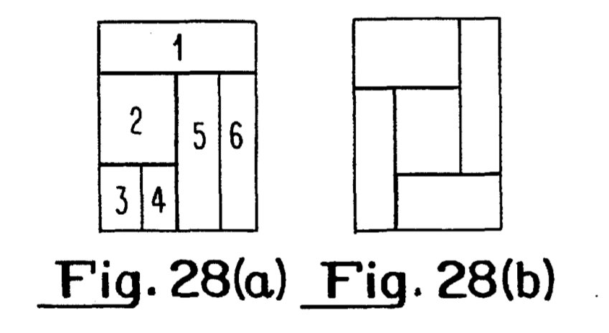

As has previously been emphasized the output from the edge extractor is a page of character outlines or blobs and the present arrangement and this contributes to the present arrangement being flexible +
enough to read text in many different fonts. It also renders the page segmentation less susceptible to differences in font size. Page segmentation is followed by a process to determine which of the blocks contain text and to perform final classification of their contents.
The process involved in page segmentation will be described initially. Essentially it comprises three stages, preparation, consolidation and partitioning itself.
Preparation will be dealt with initially. The actual partitioning algorithms work with a low resolution representation of the page. They need to know which parts of the pages are occupied by blobs or potential characters. Preparation is the first stage towards this. It takes a page of blobs and represents it in terms of a low resolution map where each cell in the page has value -1 if it is occupied or 0 otherwise.
First the bounding box of each non-spurious outline is dilated, i.e. expanded by a set amount. This amount can be fixed and can be chosen empirically (how??). It should be noted that excluded from this step are all outlines which are likely to be lines or dots, and any outlines which have an abnormally large number of features associated with them. It has been found that this expansion is a coarse, but effective way of merging outlines which are close to each other in order to keep them in the same block. The box is expanded in three directions only since if boxes are expanded downwards large banner headlines run the risk of being associated with columns of text below them. The use of a factor rather than an absolute amount for dilation reinforces the font independence of the algorithms since white space within the block is related to font size.
In the current embodiment of the low resolution representation of the page, the resolution in each direction (what do they mean by direction???) is 1/8 of the resolution of the page. Each positional cell within the page is assigned an integer value. Initially all cells (what does a cell mean here????) which are covered by the expanded box of a blob have value -1 and all other cells have 0.
Turning to consolidation, an underlying assumption of text ordering is that text is arranged in rectangular blocks. After preparation the next step is to find rectangular areas within the low resolution map which are mainly occupied by blobs. The input to consolidation is a map with values 0 and -1. Its output is a map with information about these rectangular blocks. The map is searched for chunks of blobs, i.e. areas of the map with value -1 (cells? What is the difference between a cell and a chunk?? is a cell some originally set region in the low resolution version of the image while a chunk is a group of merged bounding boxes?). When a cell is found with value -1 the process tracks the edge around the area of occupied cells to which the cell belongs (a cell can belong to other cells?? I wish I knew what a cell was). A positive block number is associated with the chunk. During tracking all cells around the edge are assigned the negative of the block number. The algorithm uses the block number and its negative. Thus block numbers start at 2 since -1 is already used. They are allocated in ascending order. However they do not represent the eventual reading order of the page since this is established at the partitioning stage.
The segmentation algorithm relies on finding clear horizontal and vertical paths between the chunks of blobs. Sometimes a page may be skewed in which case, although these paths are obvious to the naked eye they may not be picked up by an algorithm which works with maximum extensive chunks. In order to reduce the risk of this the bounding rectangle of each chunk of blobs is eroded, i.e. shrunk on all sides by a set amount. This allows a simple negative value test for blobs which overlap the eroded rectangle while ensuring that a chunk will not be processed more than once (processed how??) since the process identifies a new chunk by -1 to the right of a 0 rather than a negative value to the right of the 0 (chunks that are not part of the expanded box of a blob are labeled 0 while others are labeled -1, block numbers are not used here I guess, just a negative value test..). The process is illustrated in FIG. 29 where the left-hand view shows simple text chunks on a skewed page and the right-hand view shows the effect of the erosion process referred to above.
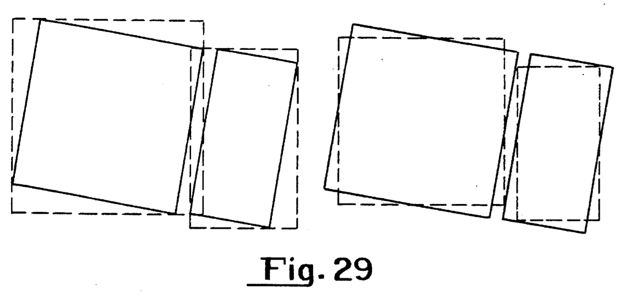

All cells within the eroded rectangle of a block are assigned the block number as their value. This includes cells which have a value 0 prior to consolidation. Cells which belong to the original chunk (what is a cell and what is a chunk?), but which overlap outside the eroded rectangle have a negative value, -n if they are at the edge of the chunk, -1 otherwise.
Finally the page is partitioned into blocks according to the cells with positive value. To start a routine searches from left to right and top to bottom for a complete vertical path through the page between eroded rectangles with different positive values. When this is found another routine is called to search the left-hand part for a complete horizontal partition, while the first-mentioned routine continues to search in the right-hand part for further vertical partitions. If no partition is found the whole page is searched for a horizontal partition. Partition is terminated by the second routine when no further horizontal paths are to be found.
This algorithm assumes that the document can be partitioned into rectangular blocks by successively cutting into rectangles in a manner similar to that of a guillotine. The reading order is assumed to be that of a newspaper and the blocks are read top to bottom and left to right, but a wide column above a narrow column nests the narrower columns. The result is illustrated in FIG. 28(a). Thus the input to text ordering (FIG. 22) is a page of blobs and the output is a set of blocks which comprise rectangular loading boxes with contents.
In association with page segmentation the blobs are classified. Each blob within a block is passed through the feature extractor described above, and the number of potentially "spurious" blobs are noted. A blob is classed as spurious if it matches no known ASCII character, or if it is a dot or a line. The proportion of potentially spurious blobs to the total number of blobs is calculated, and if this is high the block is deemed to be non-text. Blocks which just contain single isolated blobs are noted as such, and not treated as text.
Ordering of text blocks: If the partitioning sequence described earlier is followed, then the blocks will be identified in "newspaper" reading order. Note that the block ordering problem is not unambiguous, but it is considered the most "reasonable" way of ordering, and is probably the best without recourse to a higher level of information (such as user intervention).
Ordering of text within blocks: The blobs within a block need to be associated into rows, and then the blobs and rows ordered. The text ordering process makes no assumptions about the order in which the blobs are received.
As each blob within the block is considered, its maximum and minimum y (vertical) position is noted. If the blob is the first considered, these y values are noted as the maximum and minimum y values for the first row. For each subsequent blob, it is noted whether it falls within an existing row. If it does, it is associated with that row and the row's maximum and minimum is modified. If it does not, then a new row is started.
Having considered all the blobs within the block in this way, a pass is made through the rows to check whether any rows noted need to be merged. For example, if the first two blobs considered for a row were a lower case i and its associated dot, then two distinct rows would have been started. A merging pass is therefore needed to associate these two rows into one.
When all the blobs have been associated into rows, the blobs within each row are sorted into x (horizontal) order. The rows are then sorted into decreasing y (vertical) order. The association and ordering of blobs within text blocks is then complete.
Deduction of whitespace. Once the text blobs have been correctly ordered, the position of whitespace characters within them needs to be deduced. This is done by applying a set of metrics to the spatial relationships between the blobs within the block.
Each blob is associated with its right hand neighbor, and the distance between the blob's mid point and its neighbor's mid point (the spacing) is noted. The distance between the blob's right hand edge and its neighbor's left (the kerning) is also noted. Finally the blob's width is noted (see FIG. 30).
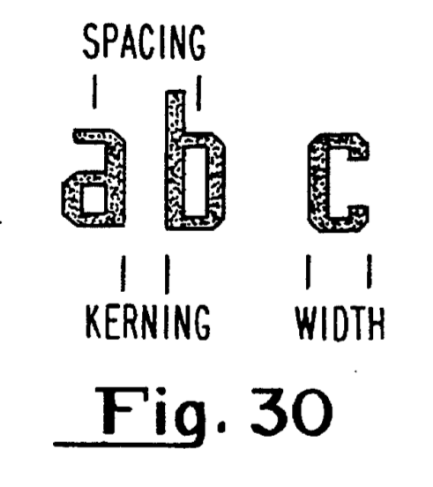

A decision is then made as to whether the text in the block is likely to be proportionally or non-proportionally spaced. This is made on the following basis (where IQR(x) is the inter quartile range (range is the difference between the largest and smallest values and quartiles are the three points that divide a data set into four equal groups, each representing a fourth of the population being sampled, the second quantile is the median, the IQR is the difference between the third and first quantile) of x). If IQR(spacing) is greater than IQR(kerning) then the text is proportionally spaced, otherwise it is non-proportional. The IQR was chosen as a measure because it is insensitive to the distribution's tail shape (which changes with justified/non-justified text), and it is stable with small sample set sizes.
The whitespace algorithm now depends on whether there is proportional or non-proportional text. For proportional text, the median kerning value is used and whitespace is inserted where the kerning value is greater than 2.0x this. (The 2.0 used here is an empirically evaluated figure. Note that the use of mode is intuitively correct, but may give stability problems for low sample set sizes, or high measurement resolutions. For this reason the median value is used.
For non-proportional text, the median spacing value is used and whitespace is inserted where the kerning value is greater than 1.5x this. (The 1.5 used here is intuitively correct from the model of non-proportional text).
Association of blobs in deliberately broken characters. A feature of deliberate breaks (such as the body and the dot in lower case i) is that the two blobs within the same row overlap in x. Where this happens, the smaller of the two characters is assigned as the dot, and this information is passed on to the tests part of the text ordering process (see later).
Identification of potentially merged characters. A blob is identified as merged if it is over wide. This is determined from the distribution of the blob widths. A blob within a text block is also defined as potentially merged if it does not match any known ASCII character. Potentially merged blobs are candidates for segmentation by the merger/segmenter 15 (see figure 1). The choice as to whether the segmentation was correct is made by the final classifier 16 (see figure 1).
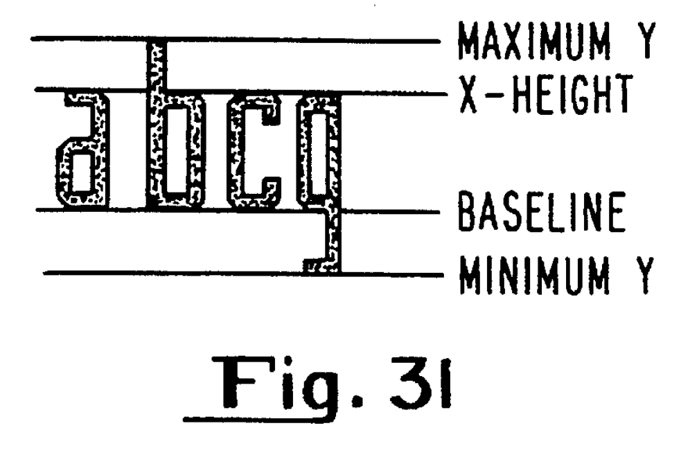

Resolution of intrinsic ambiguities. Feature extraction as described above matches a blob to a set of possible classes of ASCII characters, where each class contains characters which cannot be resolved by features, but can be solved when their size or position within a row is considered. In order to do this further data relevant to each row is required. The maximum and minimum y (vertical) are already noted for each row when the blobs are first associated into rows. It is also necessary to note the baseline position, i.e. the line on which characters without descenders sit, and the x-height, i.e. the vertical position of the top of a lower case "x" (see FIG. 31). In order to deduce these extra row metrics, an indication is required of each blob in the row's character type (with or without descender, "x"-height or with ascender). However this information is not available at this stage in the processing. Instead, a list is made of the classes which contain characters with descenders, and a list of the classes which are unambiguously lower case without ascenders. The information from a blob for baseline measurement is only used if it is a good match to a class which is not in the former list, and for x-height measurement if it is a good match to a class in the latter list. Values thus gained are smoothed (smoothed how??) into running totals in order to reduce sensitivity to error.
Within a row, each blob which has not been identified as a dot is tested to give a set of blob metrics which are used to help discriminate between possible characters within a class. The metrics used are: REL_HT, the relative height of the blob as compared to the distance between MAXIMUM Y and MINIMUM Y; V_POS, the vertical position of the centre of the blob as compared to MAXIMUM Y and MINIMUM Y; and FILL. FILL is a special metric, used to discriminate between upper and lower case versions of the same character, by looking at the proportion of the blob in the region between X-HEIGHT and MAXIMUM Y.
The tests section of the text ordering process makes the decision as to which character from each class is the most likely by checking a database on the ASCII characters. This database contains information on each character's height, vertical position and whether or not it is dotted. This information is called the character's description. Each blob metric is split into zones, and a character's description is stored as a word where a set bit indicates that the corresponding blob metric may fall within this zone. Each blob has its own description formed, and from this a single ASCII character is chosen for each possible class passed on by feature extraction. If no character within a class fits well, then the match rating of the choice is reduced (the match rating is the measure of confidence produced by feature extraction). The output from the text ordering 12 to final classification for each blob is therefore one or more ASCII characters, together with a match rating for each.
Thus the text ordering facility provides the capability to analyze and make use of the structure of a slightly restricted but nonetheless representative set of compound documents. This is a significant feature of the present system.

Final Classifier
A description will now be given of the final classifier 16. The feature extraction and blob classification steps (the "heart" of the recognition process) do not produce final decisions on the ASCII value associated with each blob, but instead provide data indicative of a set of classes of characters which the final character might be part of. Each class has a confidence value or match rating associated with it.
At this stage, therefore, there are a number of classes, each containing a number of ASCII characters, from which the final character can be chosen.
The membership of the classes is carefully chosen such that members of the same class have similar feature, but may be distinguished by the contextual geometry (position on line, size, presence of dot etc.). Thus "C" and "c" may be present in the same class (they can be distinguished by height), but "O" and "0" must be in separate classes.
Because of this choice of class membership, the choice of which character from within each class can be chosen at the Text Ordering phase as described above.
After text ordering, therefore, a choice has to be made from a set of characters for each blob. The choice now is such that there are match ratings to help, but no further information from the physical layout or appearance of the blobs.
The final classifier makes use of text models to carry out its final classification. A description will be given first of these models followed by the way in which they are used to make the final classification.
Each model makes some assumptions about the structure of text. These models are in general language specific, in that different languages may need different databases, or may not conform to the models at all (this is especially the case with computer languages). The models described herein are likely to be valid for all European languages, albeit with a possible change of database.
(1) Lexical rules: Simple character-level syntactic rules can be developed assuming that the text unit can be identified as the set of characters between whitespace delimiters. Characters are classified as follows: A character can be alphanumeric or punctuation. An alphanumeric character can be alphabetic or numeric. An alphabetic character can be upper or lower case. If the first alphanumeric character in a text unit is alphabetic, then the string of characters from the first alphanumeric character to the last alphanumeric character is called a word. The lexical rules are then:
- a) Numeric characters do not appear within words.
- b) Upper case characters do not follow lower case characters in words.
- c) Punctuation (except apostrophe) does not appear in words.
(2) Markov Methods: A markov chain is a discrete stochastic process which can take one of a finite number of states at each increment. The probability of achieving state j in the next increment, when the current state is i, is purely a function of i and j and nothing else. Thus the process can be completely described by the transitional probabilities P(i,j), which are usually described in the form of a transition matrix T. If there are n possible states, then T is nxn. If we define a state probability vector sk such that the ith element of sk is the probability of being in the ith state at the kth increment, then we can write:
sk+1 = Tsk
Text is not a true Markov process, but it can be modeled as one with some success. This is because of both spelling conventions (such as u following q) and the need for words to be pronounceable (so that g is unlikely to follow j). For each alphabetic character (ignoring its case) as a possible state, and each character occurrence as an increment, then it is possible to use the 26x26 transition matrix to help in selection of the next character. All that is required is to modify match ratings in order to reflect the probability of making the given transition.
A Markov chain can be applied "backwards" by considering the transition probabilities from the character to be finalized and the next. (So by backwards or forwards I'm assuming that this entails either analyzing the word from right-to-left or left-to-right respectively?)
Making the choices either "backwards" or "forwards" as described above is not ideal, as it assumes confidence in the letter (state from which the transition is being made. This problem goes away when decisions are not made on the character level, but at the word level, as described below.
The above could be extended to making a choice based on the previous m-1 characters. However this requires consideration of the states as the 26(m-1) possible combinations. This suggests a transition matrix of 26(m-1)x26(m-1). In fact, only 26m entries are non-zero, as not all transitions are possible (e.g. it is not possible to go from state "abc" to "xyz", only "bca", "bcb", "bcc" etc. ) The transition table needed for the above becomes large quite quickly, and their use for m greater than 2 is debatable (bigrams). Rather than using large values of m, dictionary methods are better, as described now.
(3) Dictionary Methods: Text units (strings between whitespace) can be reduced to words which are either in a dictionary, or can be derived from entries in the dictionary using a specified set of production rules. Methods of generating, i.e. and production rules are known, see for example "Development of a Spelling List", M Douglas Mcilroy, IEEE Trans. Comms. January 1982.
The final classifier can use the dictionary search method in the manner described in "A minimum Distance Search Technique" by B. Aldefeld, Bell System Technical Journal, October 1980.
The final classifier uses the above as follows:
The character blobs on a page are divided into blocks, ordered within these blocks, sorted into rows and whitespace (which?) is deduced by the text ordering phase as described earlier. The appropriate character is chosen from each of the classes as described above by the "tests" part of text ordering. The final classification phase assembles the text units (between whitespace), and generates each possible text unit from the character options passed to it. Each possible text unit has a total rating, which is simply the product of the individual probabilities for each of the character options. Each possible text unit can then have its total rating modified to reflect how well it conforms to each of the text models, as shown below.
The text units are stripped down into words, as described in (1) above by procedure punc strip() (….look this up). The three lexical rules then translate into the following implementation rules:
No transition from alphabetic to numeric character within words.
No transition from lowercase to uppercase characters.
No contained punctuation (except for the apostrophe).
Markov chains are applied to give a probability of having taken the given path for a word option. This obviates the need for running the analysis backwards and forwards, and as calculation is made of the path probability for a whole word, there is no need to have any confidence in any particular character.
The path probability is the product of the P(i,j) for each transition with the word (these transition matrices must be hardcoded based on the english lanuage?). A higher probability shows that the word is more likely to be correct (within the Markov model).
The Dictionary Search technique can be implemented using a commercially available program (hmmm I should find out what this is, whatever it is it must be included in the source code.. I'll check out the articles but too bad they don't describe it here.. oh well).
It should be noted that it is unnecessary to use both Markov models and dictionary methods. (Now I'm not sure whether they use markov models or not... but I wonder if these markov models and dictionaries would be useful for math or not in some fashion..) It should also be noted, however, that Markov models take significantly less space for their database.
Although certain embodiments of the present invention have been described in detail, one of ordinary skill will realize numerous variations and modifications are possible without departing from the spirit of the present invention. Accordingly, reference should be made to the appended claims to ascertain the scope of the present invention.
Claims
1. An optical character recognition system comprising scanning means for optically scanning a document to produce an image thereof, means for identifying edges within said image and for identifying edge paths to produce data indicative of the outline of each object identified in said image, and means for processing the data provided by said edge identifying means and arranged to provide data, in an appropriate format, representative of the characters in said image.
- 2. A system as claimed in claim 1, wherein said scanning means is arranged to produce a grey level image.
- 3. A system as claimed in claim 1 or claim 2, wherein the output from said edge identifying means is subjected to polygonal approximation prior to processing by said processing means.
- 4. A system as claimed in any preceding claim wherein the edge identifying means is an edge extractor for producing data indicative of the outline of objects in a grey level image which comprises a pixel array, said extractor being arranged to sequentially scan said image array for an edge and for each edge located trace an outline of the object associated with said edge, said edge extractor being arranged to locate edges by means of an edge operator which generates edge values for each pixel.
- 5. A system as claimed in claim 4, wherein the operation of the edge extractor is such that the edge value for a pixel is derived from the relative values of the grey level of the pixel which is immediately above relative to the direction of scanning and the grey level of the pixel which is immediately below relative to the direction of scanning.
- 6. A system as claimed in claim 4 or claim 5, wherein the edge operator is defined with respect to a 3 x 3 neighbourhood of x as follows
5674x0321
in which the numbers represent the chain codes of adjacent points, the edge value of an adjacent point with chain code n being
grey level (n+1) - grey level (n-1).
- 7. A system as claimed in claim 6, wherein said outline is traced in accordance with an algorithm in which, for a point with chain code n, edge values are derived for points with chain codes n-2, n-1, n, n+1, and n+2 from the current position, the point with the strongest edge values is marked, and the process is repeated to identify and mark successive strongest edge values.
- 8. A system as claimed in any one of claims 4 to 7, including a polygonal approximation facility for approximating the edge outline generated by the edge extractor by a polygon.
- 9. A system as claimed in any one of claims 4 to 8, wherein the edge outline generated by the edge extractor is represented by a closed loop.
- 10. A system as claimed in any preceding claim, wherein said processing means includes a page segmentation facility for arranging the data indicative of the object outlines into the correct order and means for identifying particular features of said outline.
- 11. A system as claimed in claim 10, wherein said page segmentation facility identifies groups of said object outlines to form said outlines into blocks of outlines and arranges said blocks into said order.
- 12. A system as claimed in claim 11, wherein the page segmentation facility can identify blocks as text or non-text blocks.
- 13. A system as claimed in claim 12, wherein the block type is determined on the basis of a classification of each object outline.
- 14. A system as claimed in claim 13, wherein data representative of the classification of each object outline is provided by an object outline classification process.
- 15. A system as claimed in any one of claims 12 to 14, wherein the block order is determined in accordance with the manner in which the blocks nest.
- 16. A system as claimed in any one of claims 10 to 15, wherein the output of said page segmentation facility comprises data representative of a class or classes to which the object represented by said outline could belong together with a weighting value, said weighting value indicating the probability that the outline is associated with a particular class.
- 17. A system as claimed in any preceding claim, wherein said processing means includes a facility for processing said data to identify particular features of each object outline and to classify the outlines into classes in accordance with the identified features.
- 18. A system as claimed in claim 17, wherein the features may comprise any one of concavity, closure, axis, symmetry or line either singly or in combination.
- 19. A system as claimed in any one of claims 10 to 18, wherein said processing means includes a final classification stage for making the final classification of each said outline.
- 20. A system as claimed in claim 19, wherein the output of said final classification stage is in ASCII code.
- 21. A system as claimed in claim 19 or claim 20, wherein said final classification stage operates on the data output of the page segmentation facility using lexical rules, Markov chain analysis and dictionary search techniques.
22. An edge extractor for producing data indicative of the outline of objects in a grey level image generated by an optical scanning device and which comprises a pixel array, said extractor being arranged to sequentially scan said image array for an edge and for each edge located trace an outline of the object associated with said edge, said edge extractor being arranged to locate edges by means of an edge operator which generates edge values for each pixel.
- 23. An edge extractor as claimed in claim 22, which operates such that the edge value for a pixel is derived from the relative values of the grey level of the pixel which is immediately above relative to the direction of scanning and the grey level of the pixel which is immediately below relative to the direction of scanning.
- 24. An edge extractor as claimed in claim 22 or claim 23, wherein the edge operator is defined with respect to a 3 x 3 neighbourhood of x as follows
5674x0321
in which the members represent the chain codes of adjacent points, the edge value of an adjacent point with chain code n being:
grey level (n+1) - grey level (n-1).
- 25. An edge extractor as claimed in claim 24, wherein said outline is traced in accordance with an algorithm in which for a point with chain code n, edge values are derived for points with chain codes (n-2), (n-1), n, (n+1), and (n+2) from the current position, the point with the strongest edge values is marked, and the process is repeated to identify and mark successive strongest edge values.
- 26. An edge extractor according to any one of claims 22 to 25 including a polygonal extraction facility for approximating the edge outline generated by the edge extractor by a polygon.
- 27. An edge extractor according to any one of claims 22 to 26, wherein the edge outline is represented by a closed loop.
28. An image processing system of the type which scans a document and which produces data representative of the outline of each object identified on the document, said system including a page segmentation facility for identifying groups of said object outlines to form said outlines into blocks of outlines and for arranging said blocks into order.
- 29. A system as claimed in claim 28, wherein the page segmentation facility can identify blocks as text or non-text blocks.
- 30. A system as claimed in claim 28 or claim 29, wherein the block type is determined on the basis of a classification of each object outline.
- 31. A system as claimed in claim 30, wherein the data representing the classification of each object outline is provided by an object outline classification process.
- 32. A system as claimed in any one of claims 29 to 31, wherein the block order is determined in accordance with the manner in which the blocks nest.
33. An image processing system of the type which scans a document and which produces data representative of the outline of each object identified on the document, said system including a facility for processing said data to identify particular features of each outline and to classify the outlines into classes in accordance with the identified features.
- 34. A system as claimed in claim 33, wherein said data is produced by an edge extractor.
- 35. A system as claimed in claim 34, wherein the edge extractor is in accordance with any one of claims 22 to 27.
- 36. A system as claimed in any one of claims 33 to 35, wherein the features comprise any one of concavity, closure, axis, symmetry, line either singly or in combination.
- 37. A system as claimed in any one of claims 33 to 36, wherein the classification data includes a rating or weighting value indicative of the strength of the match of the object outline to the class with which the object has been associated.
38. A system for processing a document to produce data representative of characters on said document in which said document is scanned to produce an image thereof and an edge identifying means processes the image data to produce data representative of the outline object identified in the image, the system including a polygonal approximation facility for reducing the number of irregularities in each outline said polygonal approximation facility operating by following the outline of each object to identify a series of points on said outline having a predetermined characteristic, measuring the depth of the concavity between each adjacent pair of points and removing concavities having depths less than a given value.
- 39. A system as claimed in claim 38, wherein said points include points where lines on said outline meet at 90°.
- 40. A system as claimed in claim 38 or claim 39, wherein said measuring step includes calculating the perpendicular distance from a line joining a pair of points to a point between said points.
- 41. A system as claimed in claim 40, wherein said measuring step includes summing the squares of said distances to find mean square deviation and maximum distance, comparing said maximum and mean square deviation with the largest side of the rectangular bounding box of the outline.
- 42. A system as claimed in claim 40 or claim 41 wherein said polygonal approximation facility evaluates a correction value for use in said measuring step.
43. A method of processing a document to produce data representative of characters on said document, said method comprising scanning said document to produce an image thereof, identifying edge paths in said image, and processing data representing said edge paths to provide data, in an appropriate format, representative of the characters in said image.
- 44. A method as claimed in claim 43, wherein the data representing said edge paths is subjected to a polygonal approximation step.
- 45. A method as claimed in claim 43 or claim 44, wherein said processing step includes segmenting the data into blocks of edge outlines.
- 46. A method as claimed in any one of claims 43 to 45, wherein said processing step including identifying a feature or features of an edge path and providing data representative of class to which the object represented by the edge path belongs.
- 47. A method as claimed in claim 46, wherein said features include concavities and closures.
- A method for processing data representing the edge outlines in an image of a document to produce polygonal approximation of said outline, said method comprising following each outline to identify a series of points along said outline which have a predetermined characteristic, measuring the depth of the concavity between each adjacent pair of points and removing concavities having depths less than a given value.

Other ocr patents::
Related to Tesseract:
2010 and 2008 (two seperate ones with same title) - Shape clustering in post optical character recognition processing
2008 - Optical character recognition based on shape clustering and multiple optical character recognition processes
2008 - Shape clustering and cluster-level manual identification in post optical character recognition processing
2008 - High resolution replication of document based on shape clustering
1993 – Noise tolerant optical character recognition system

